TABLEAU:

* Installation of the Tableau:-----> Downloading link: https://public.tableau.com/app/discover
* Loading the file.
* Understanding about the data.
* Cleaning the data.
* Dashboard can be build properly when you have clean data.

Now lets start the Visualization.

* KPI: Key Performance Indicator: KPI stands for **Key Performance Indicator**. It is a measurable value that demonstrates how effectively an individual, team, or organization is achieving key business objectives. Organizations use KPIs to track progress toward strategic goals and make data-driven decisions.

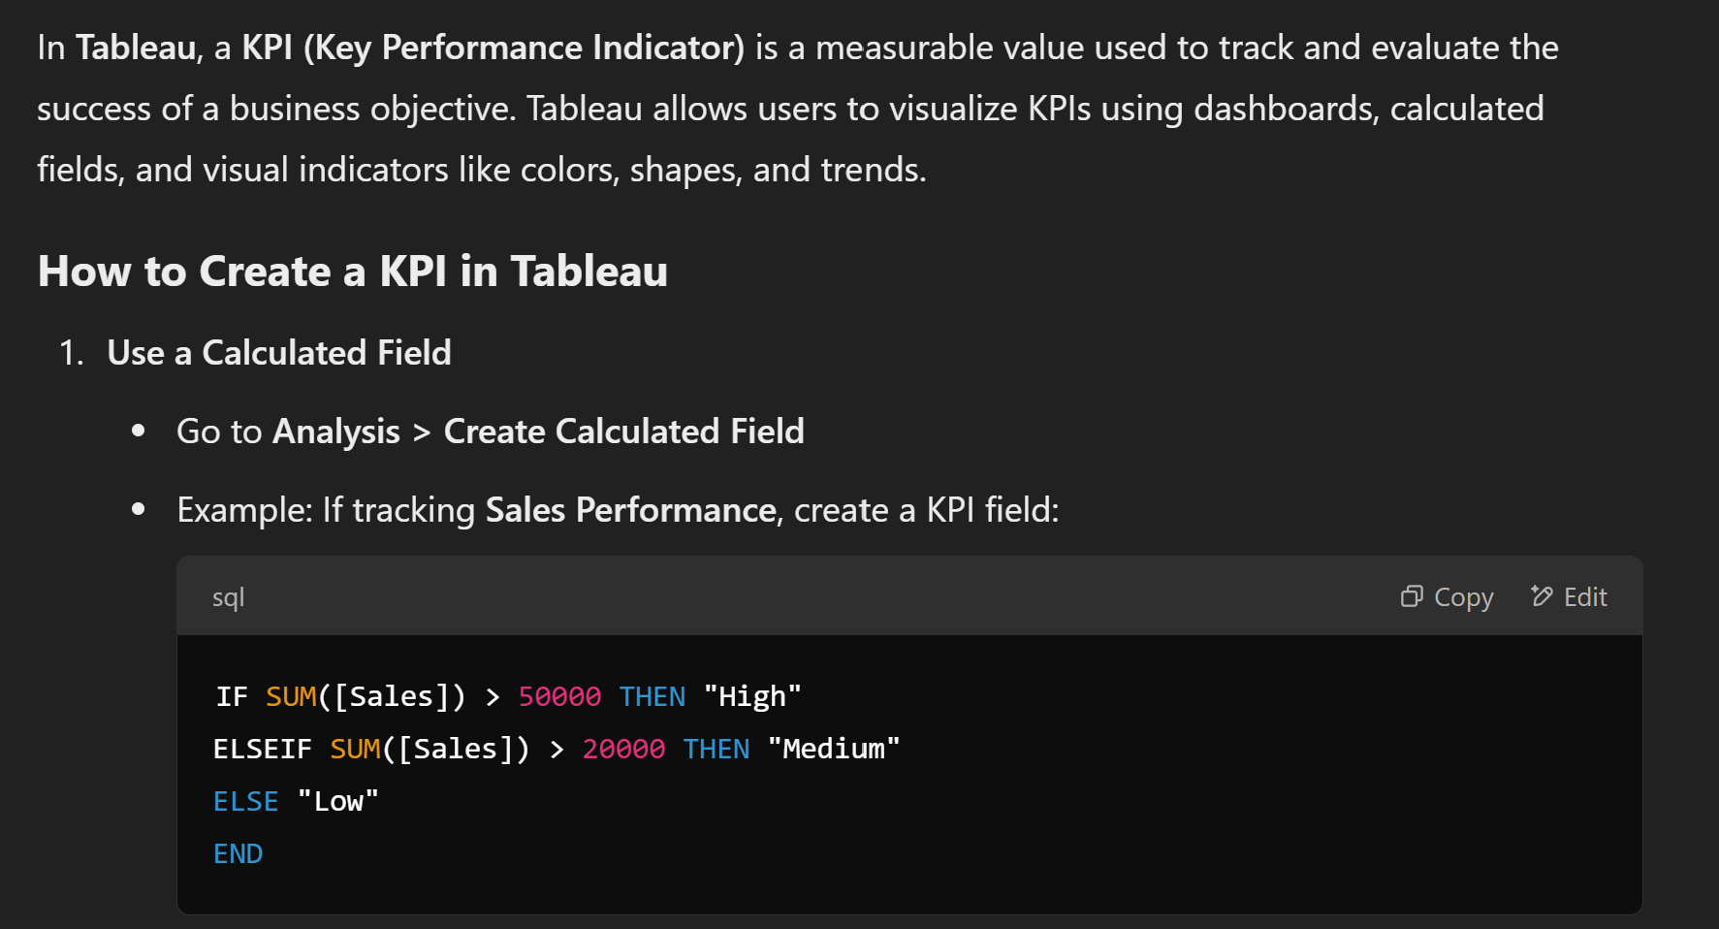

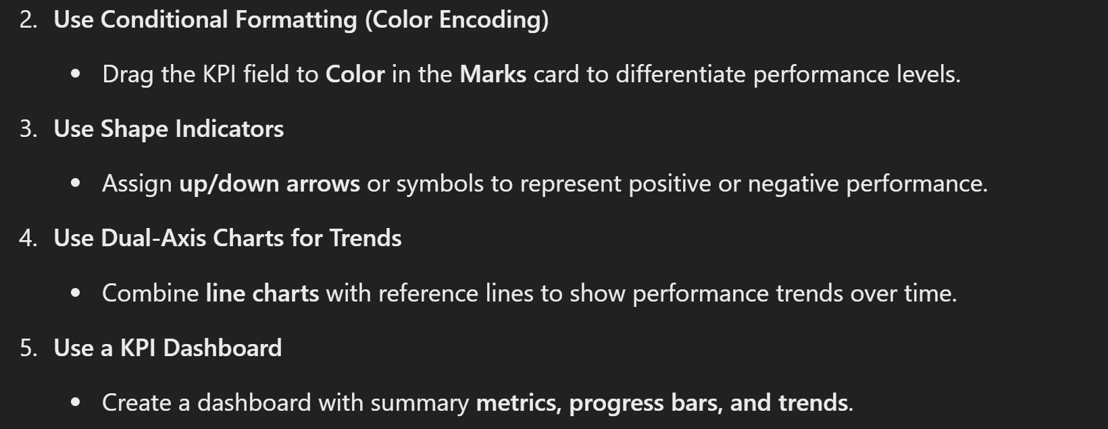

**Types of KPIs:**

1. **Financial KPIs** – Revenue, profit margins, cost reduction
2. **Operational KPIs** – Production efficiency, error rates
3. **Customer KPIs** – Customer satisfaction, retention rates
4. **Employee KPIs** – Performance ratings, productivity metrics

* Renaming the Sheet. to "KPI"
* First we have to check the Employee Count. "Double Click"
* Drag Everything then you will check which to choose: "text" , "size" etc....
* The Employee Count is 1470, see this count then ----->

Next we want the Attrition: |Yes| means left the company |No| means still working.

Now lets see how many left the company and how many are working still here.

If-else statement will be used by us for this...

Now for this go to the sheet and write the first calculation....

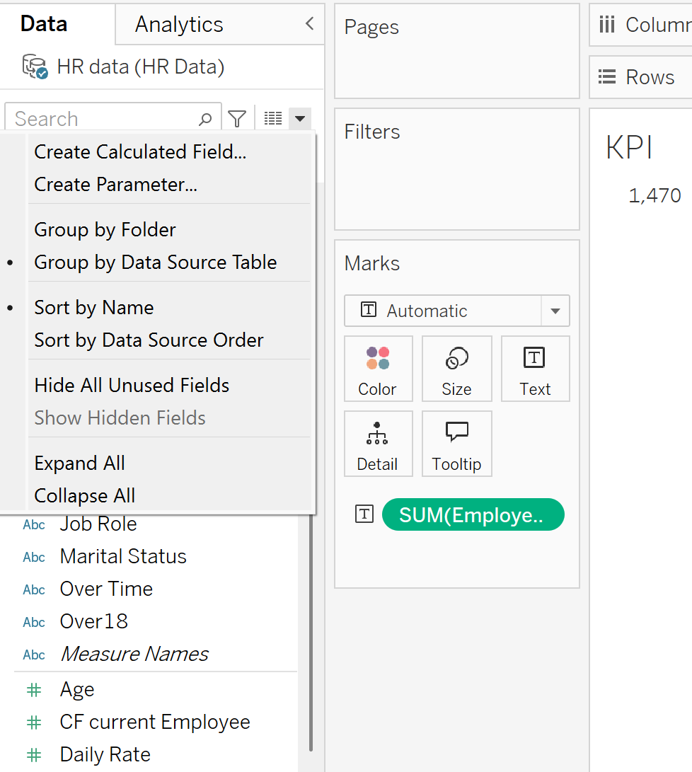



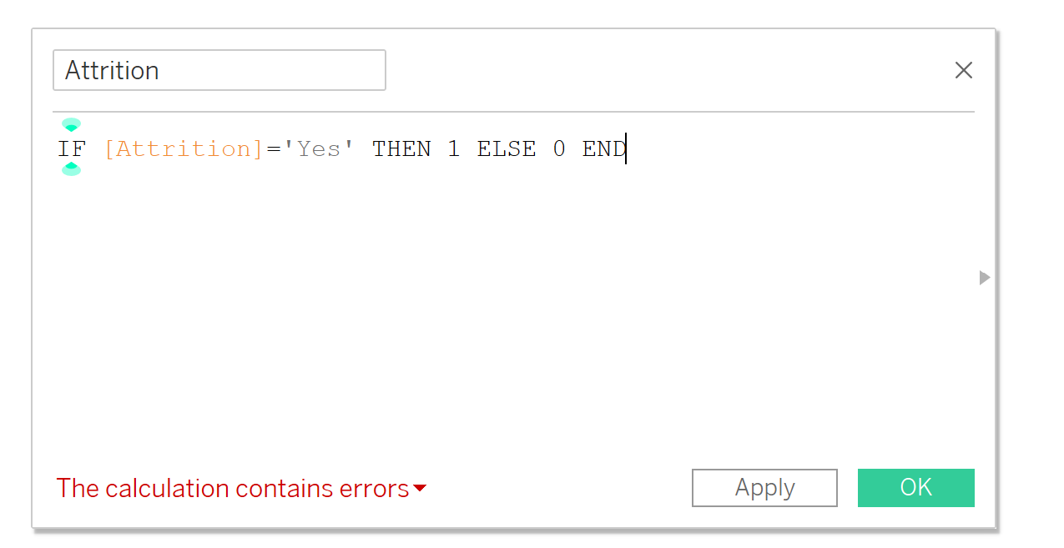



The Calculation should be unique as in DBMS…

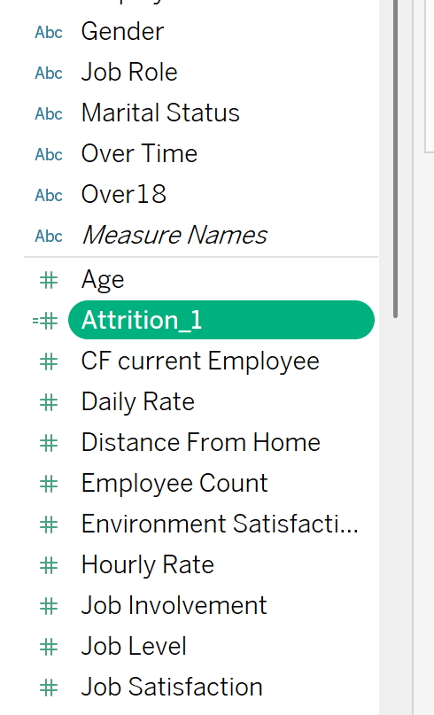 New Column Added easily.



The Sign Like “=#” Means it has been manually calculated.

As double click on the calculated field it is added there directly and then shows the calculation according to the formula…

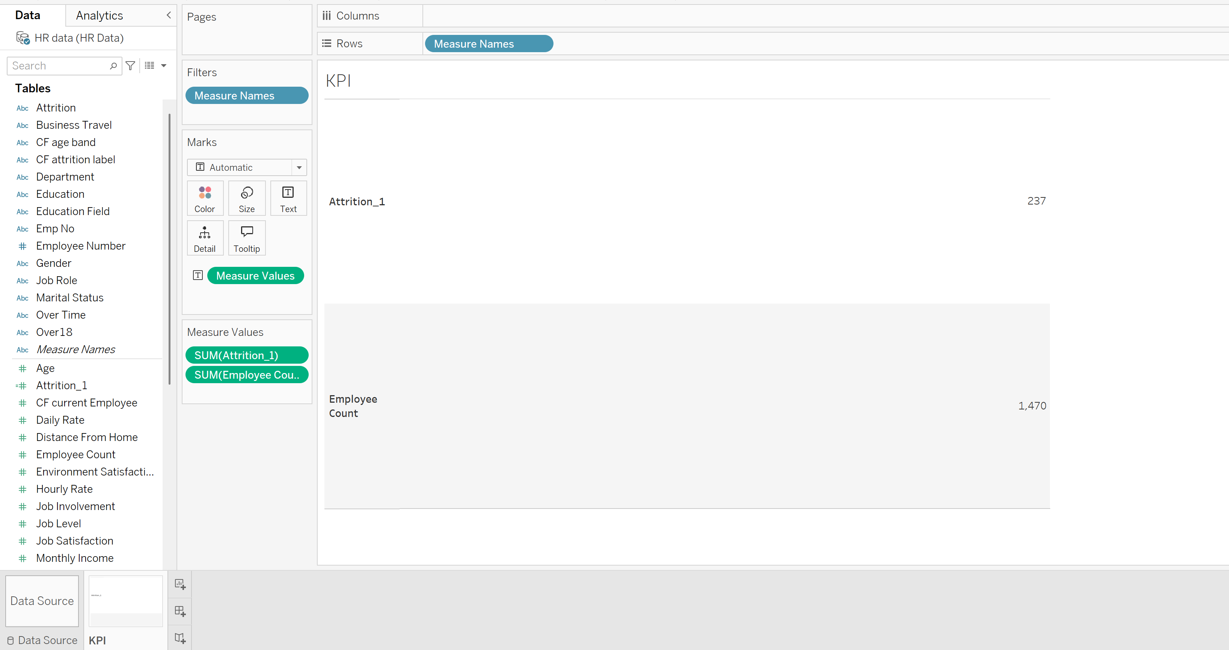



We can also invert this

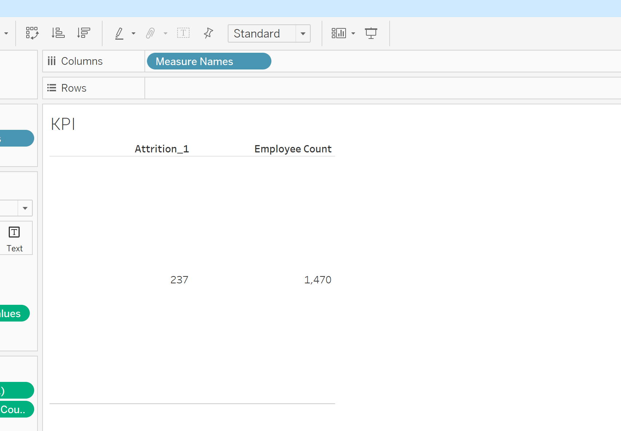



If we want to appear the employee first then we will drag it up there easily and it will change the place.

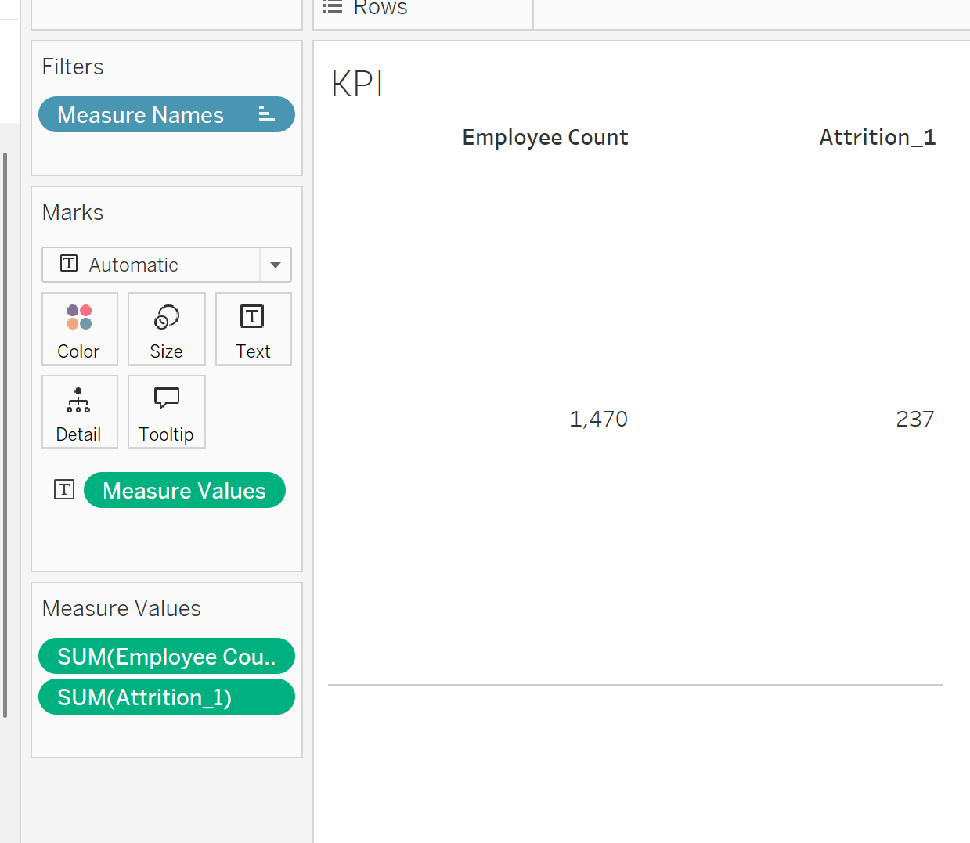



You can also check the entire view.

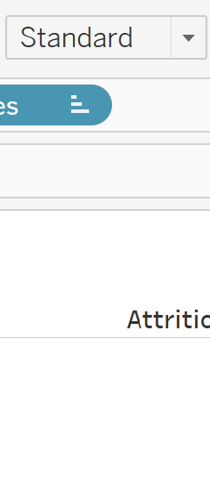



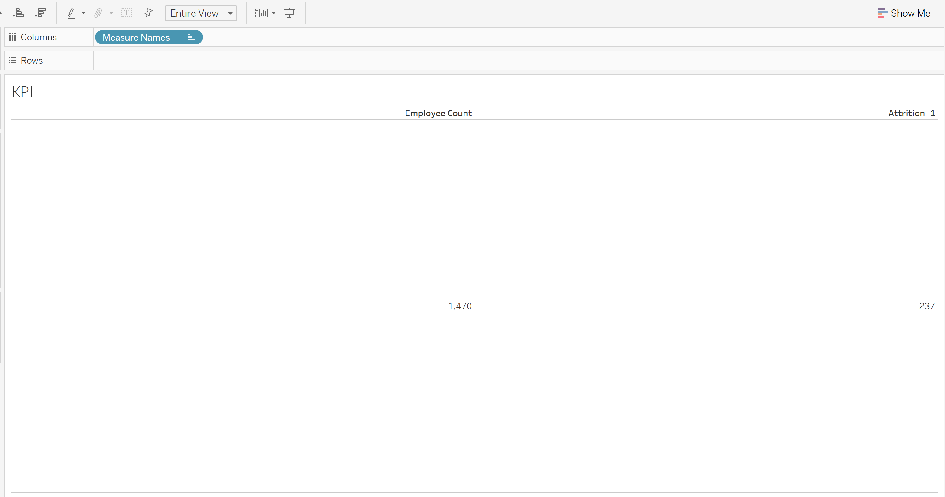



Now next we will find the attrition rate….It is in the form of percentage…

Logic: Employee left (attrition count) divided by the total count will give use the attrition rate….

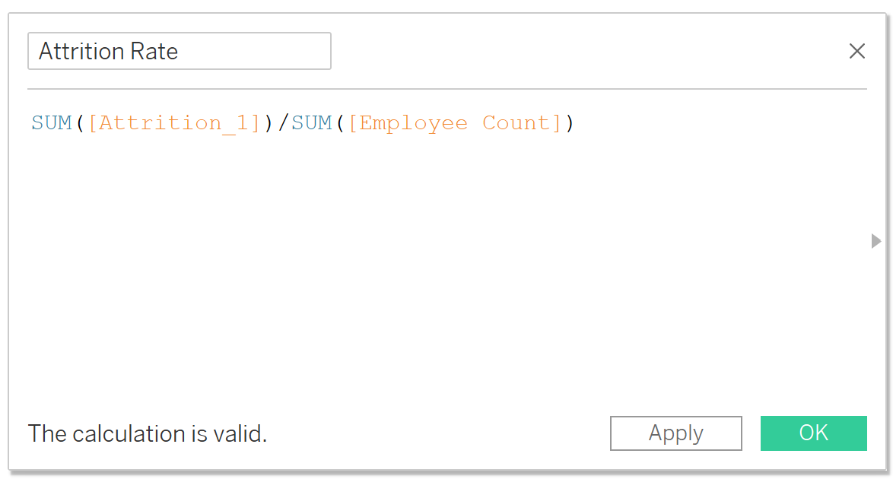



Here the rate is zero

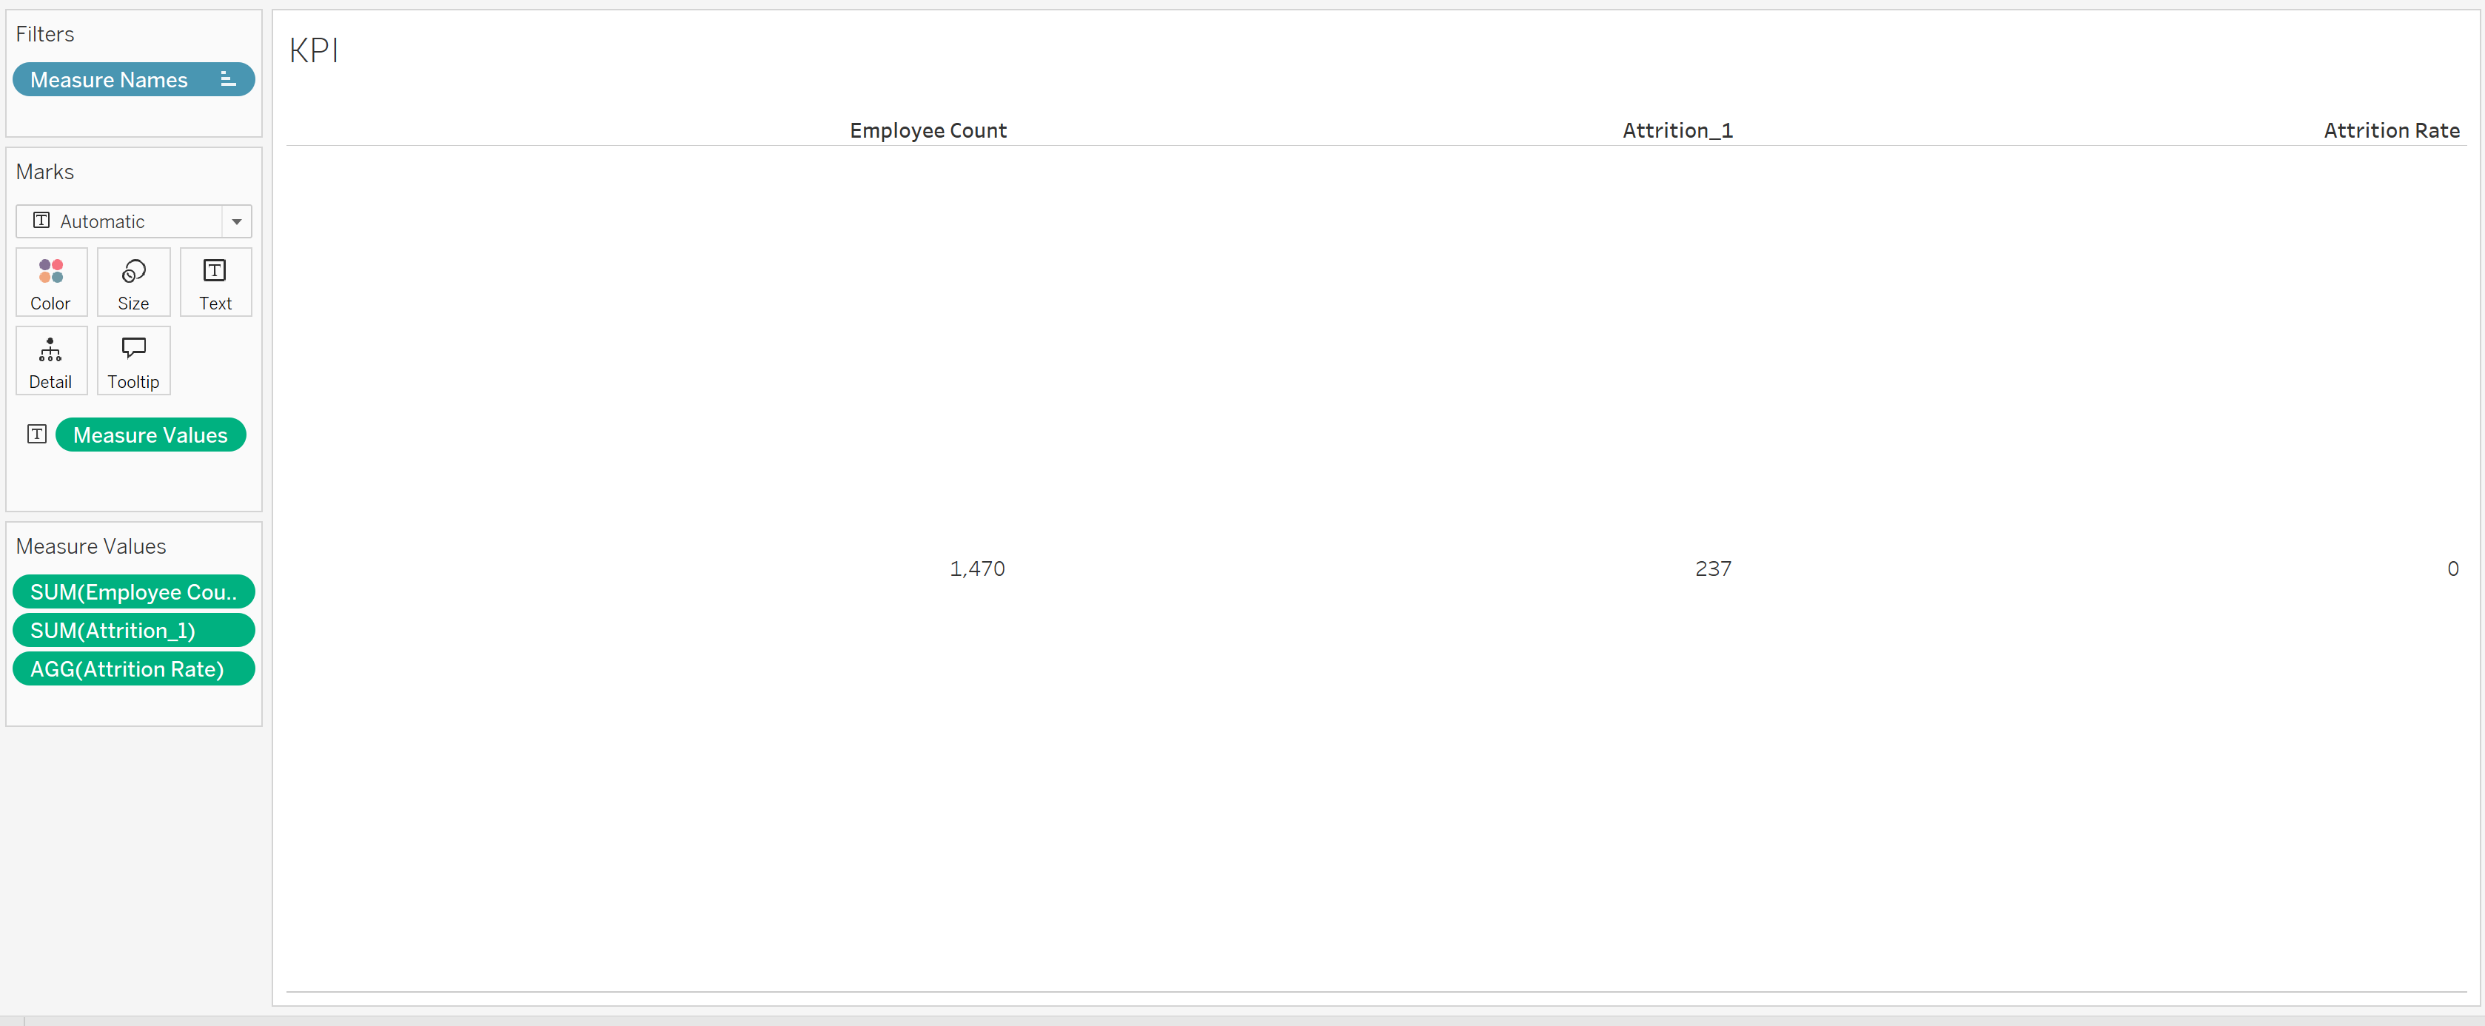



For that we will change the format of the Attrition rate. Right click on the attrition rate…..

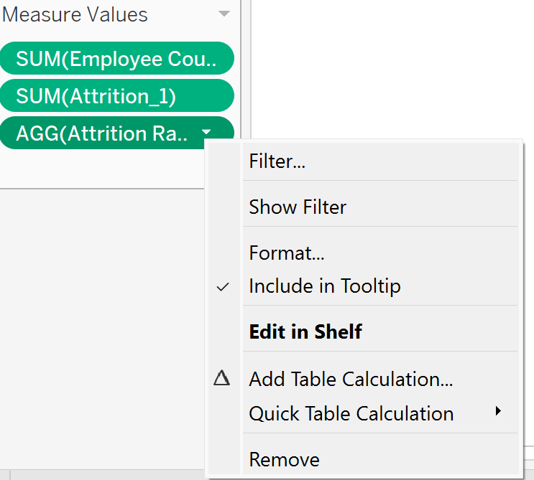



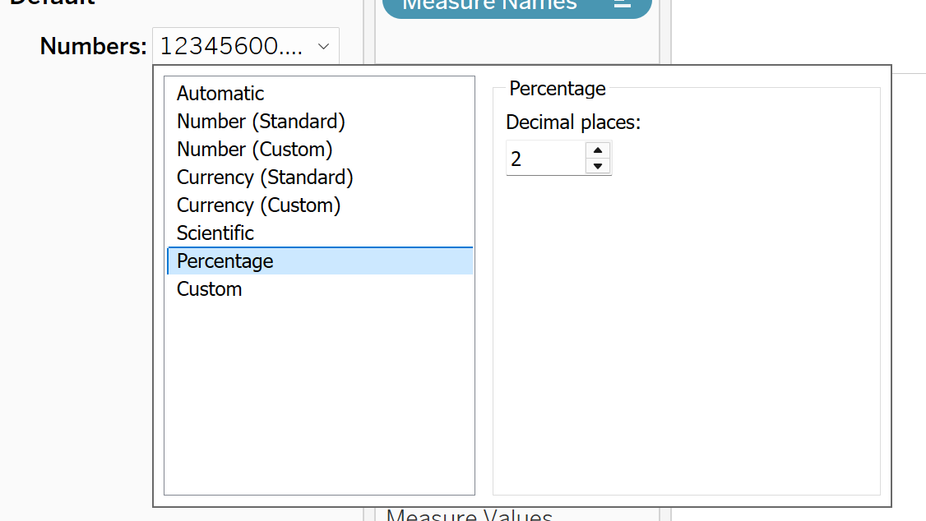



Now calculating the active employee……

So this is easy by just subtracting the

Employee count from the attrition count….

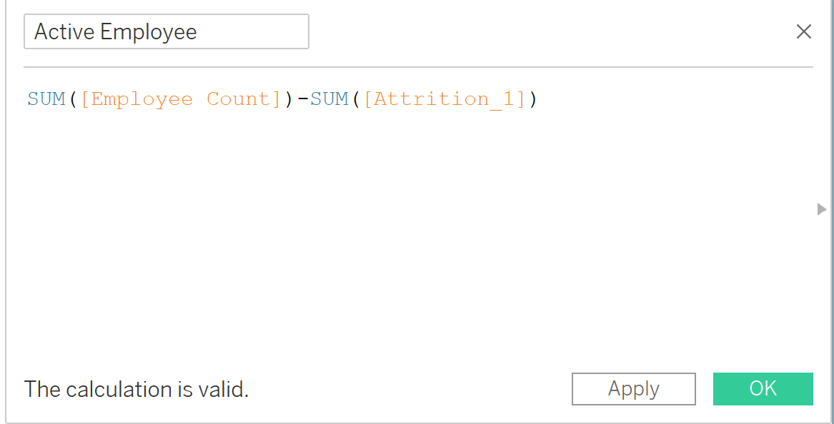



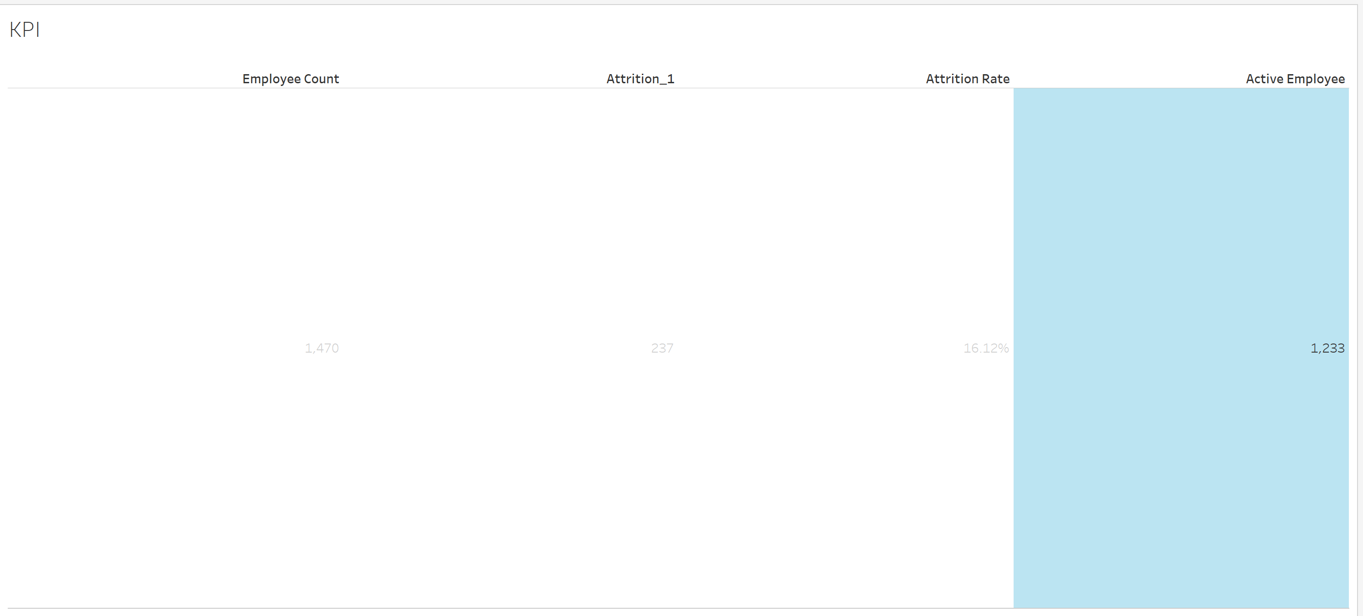



Now adding the “Age”: so easily double click or drag it…

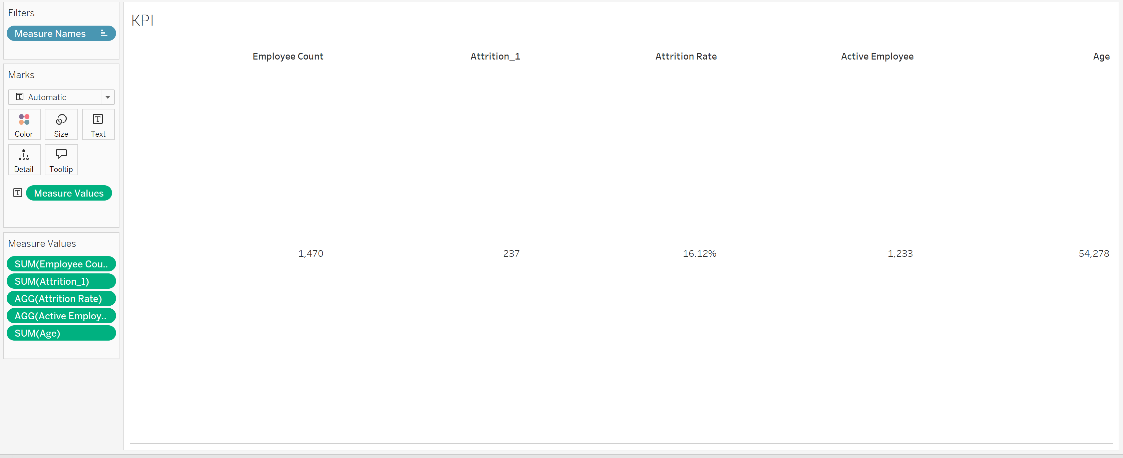



Now it gives the sum of the age we don’t want it we want the average so we have to change the measure into average….

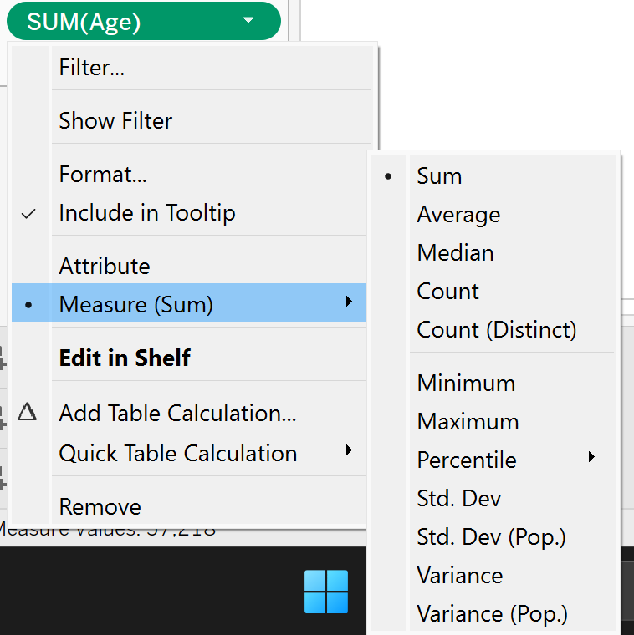



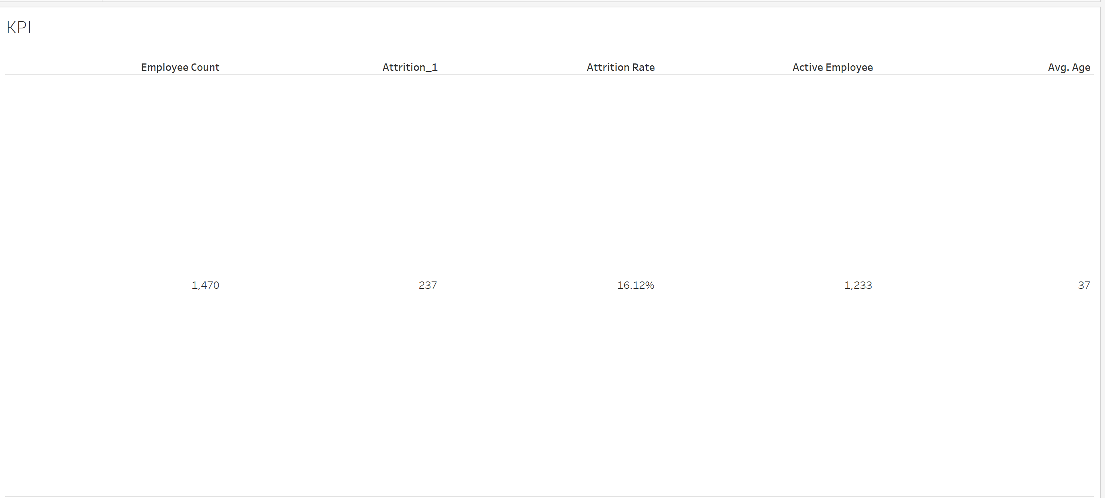



Now we are going to add the filter here coz the **KPI** changes according to the filter…..

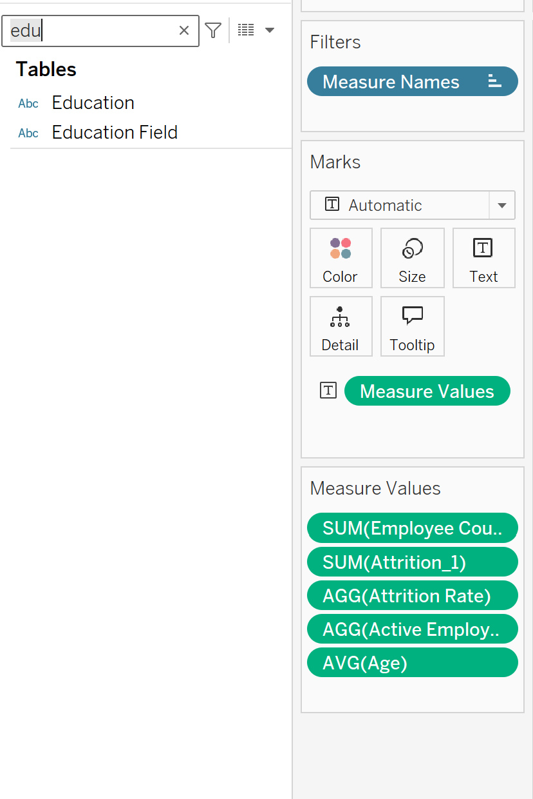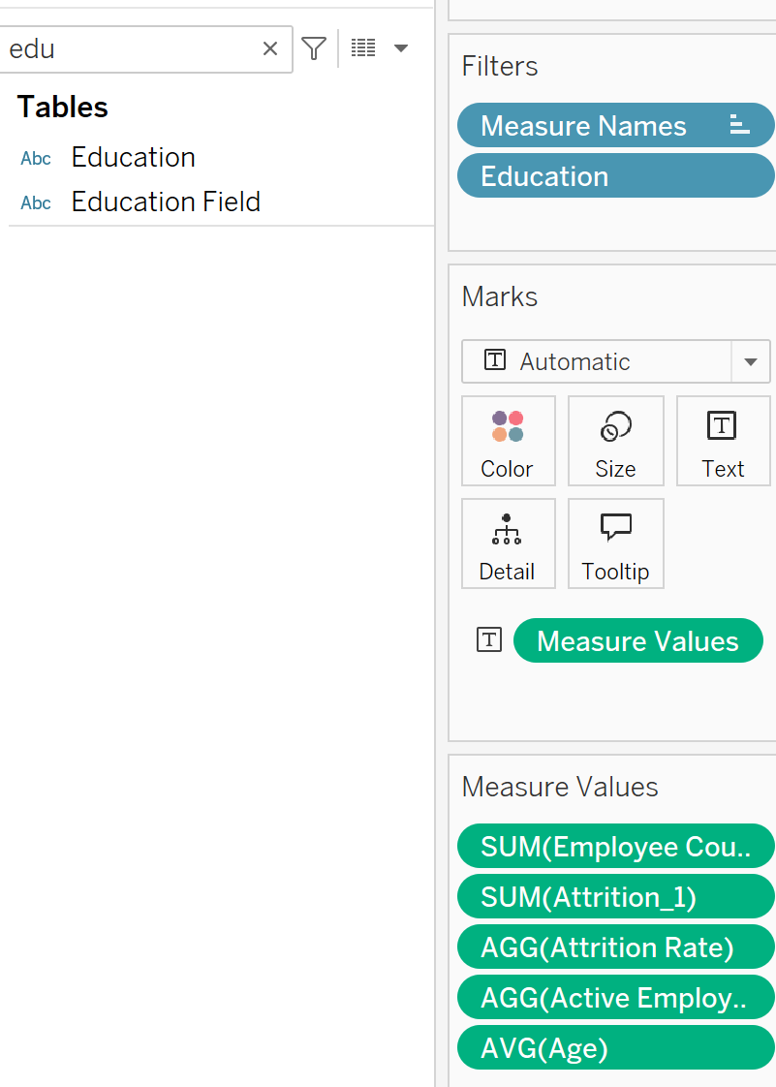



After that click on show filter and you will check the filter to the right side….

By clicking this we see that it will give us the decimal digit (floating) we don’t need it so we have to change the digits….

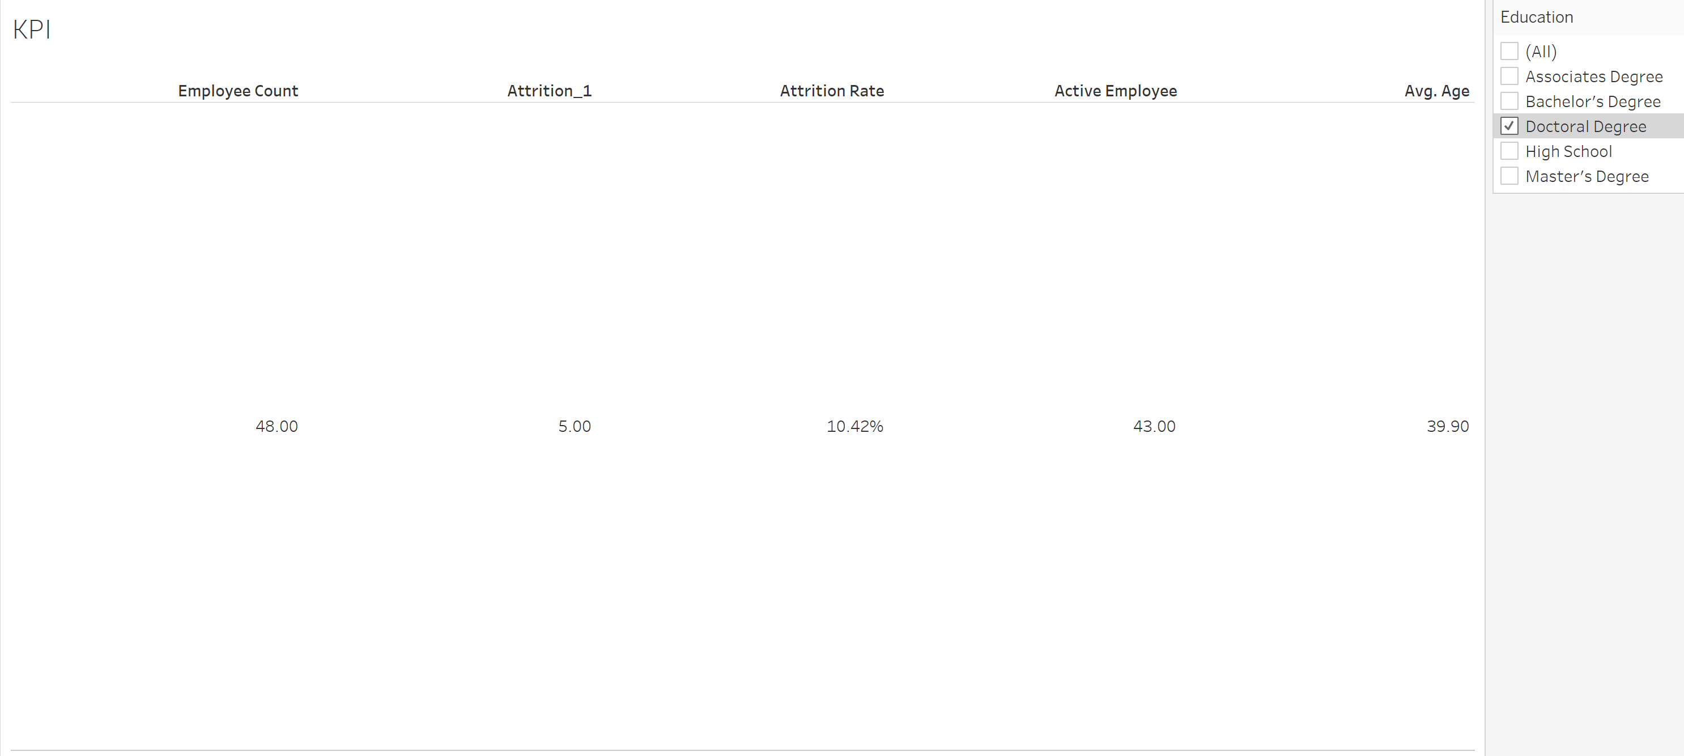



We can change it using format option in each

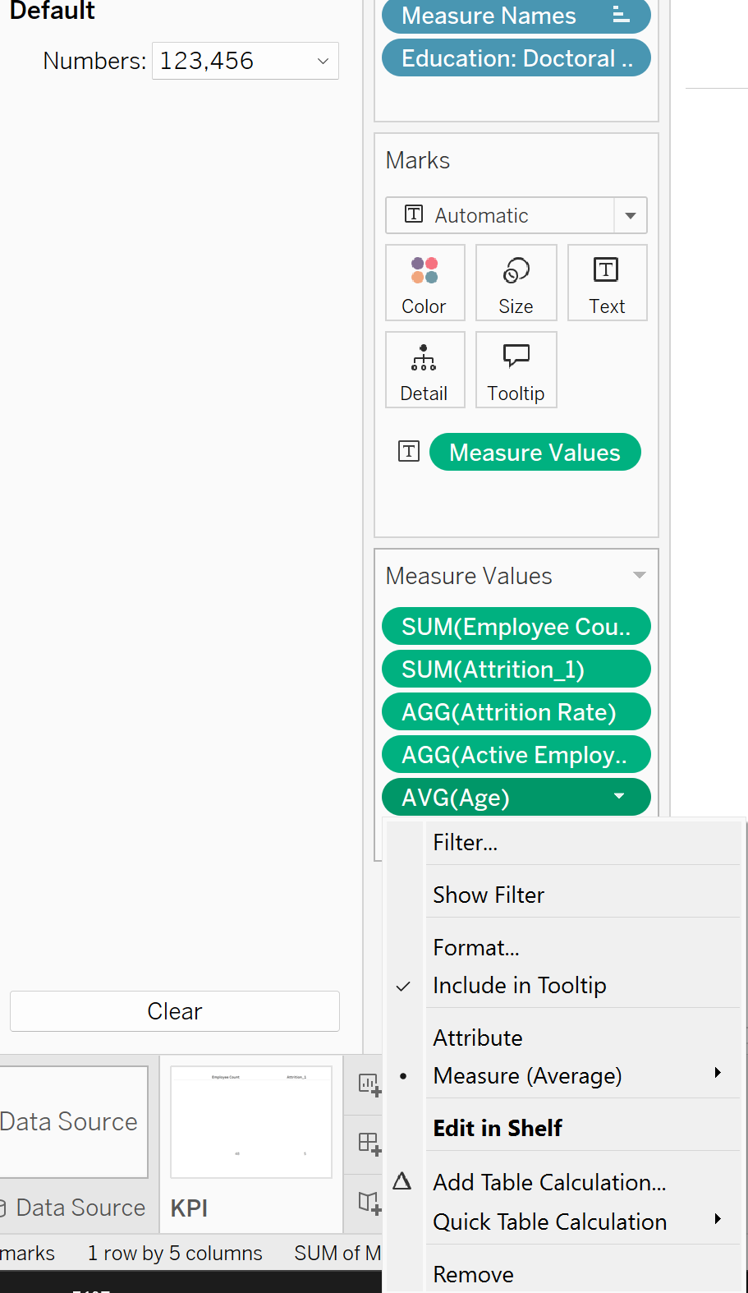



But make sure the attrition rate should be in percentage.

SO this was all about first KPI Card we design here…..

Now I will apply this KPI to all the data Source so that when the values changes the filter change the values changes accordingly…..

So I have to apply this to all the data source.

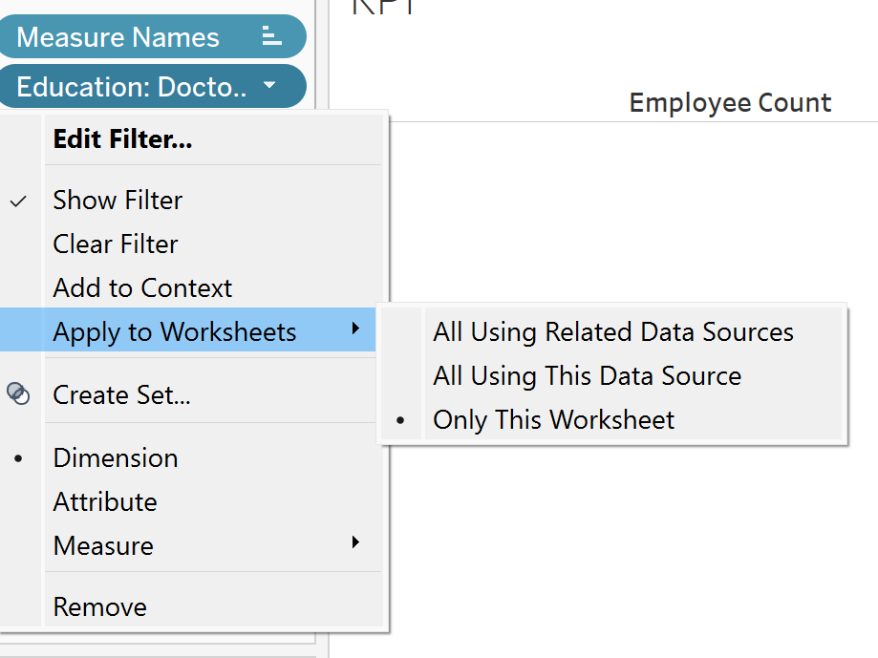



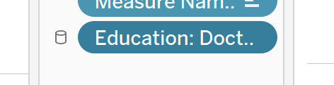



Now next chart we are designing is a Lollipop Chart (Custom Chart)

We will take new sheet for it…

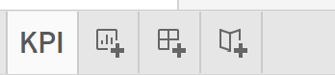 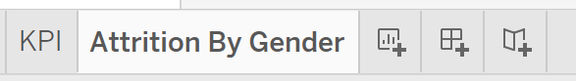



Rename it as Attrition By Gender…..

In this chart we can check how many people leaving the company by gender…..

So for this we add the “gender” in row and “attrition count” in column we have calculated by using the sql code….

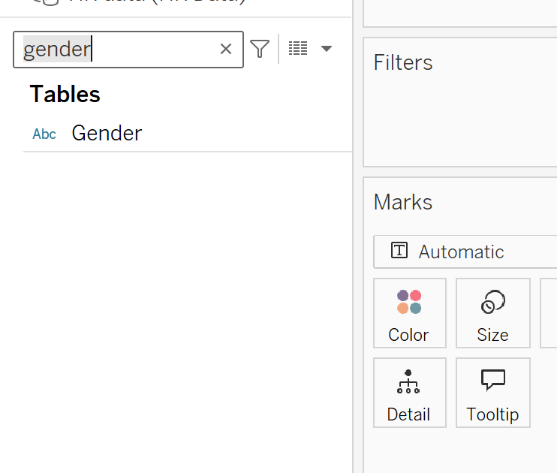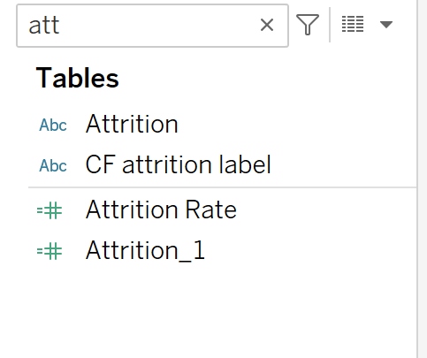



Now you can see the values it is increasing and decreasing according to the filter I applied…

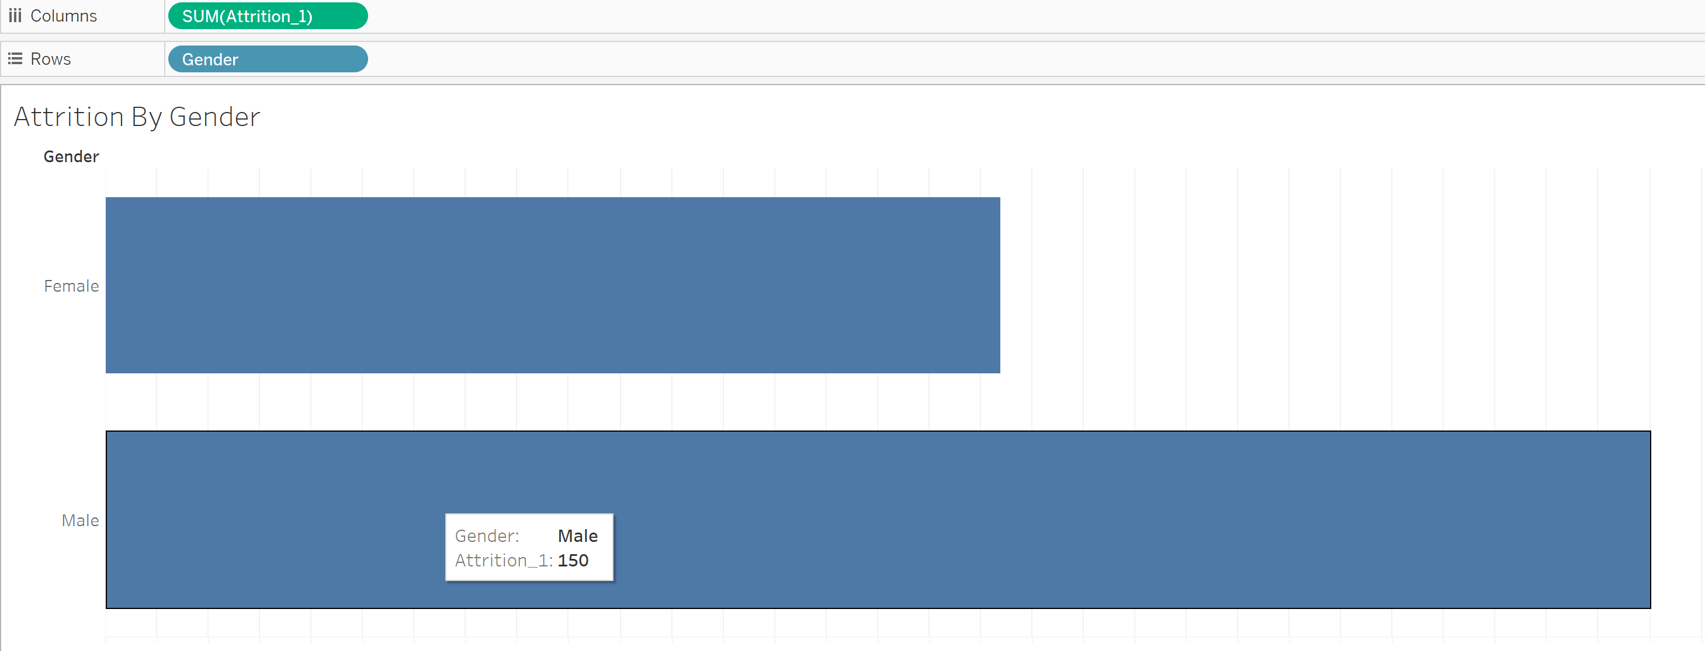



Now as we are going to make the lollipop chart so we will make the circle at the end of the bar chart…

So for this we will create one more instance os the row and columns…

Like instance of attrition_1 and Gender….

Only the attrition should be drag to the right….

For this we have to press ctrl + mouse to drag it right side….

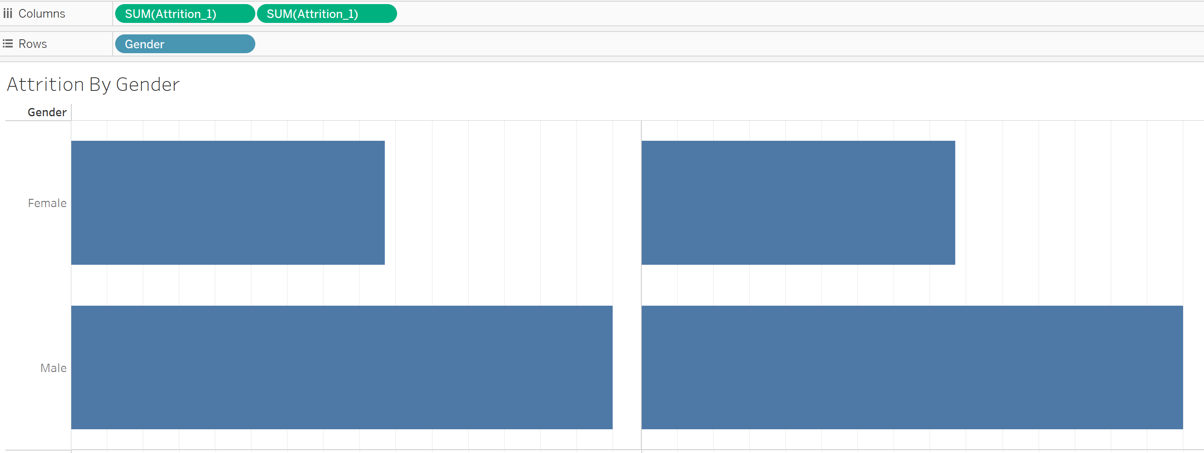



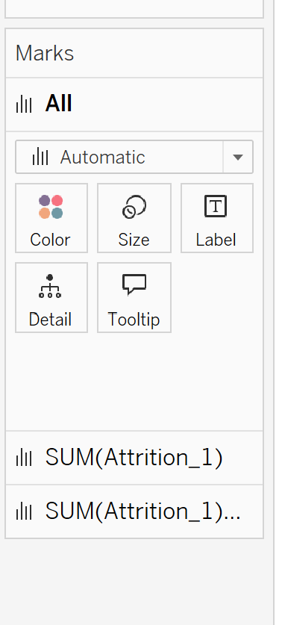Marks card also has two instances created….



Now we have to create the circle from the right side bar

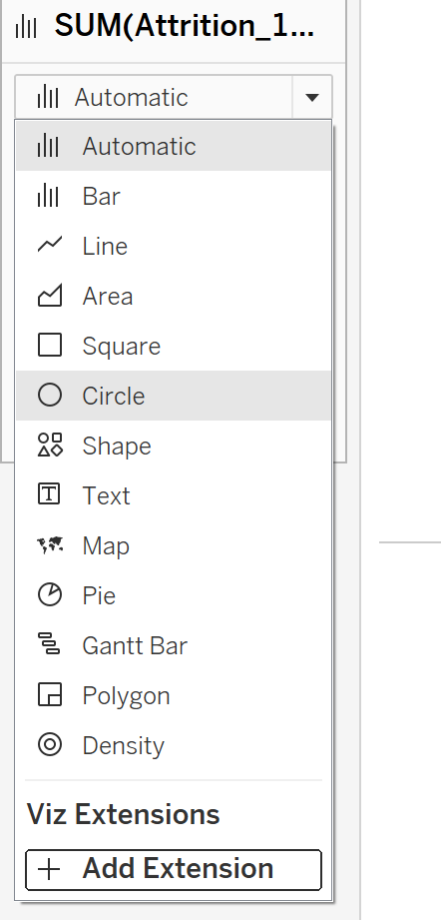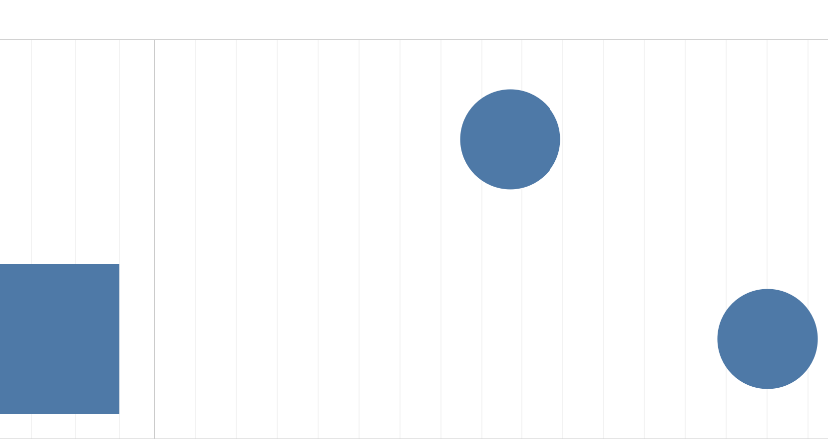



Now we have to create the dual axis chart…

For this just right click on the second attrition_1 and click on dual axis…

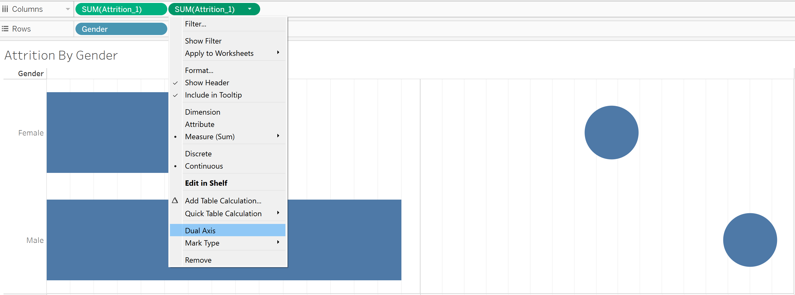



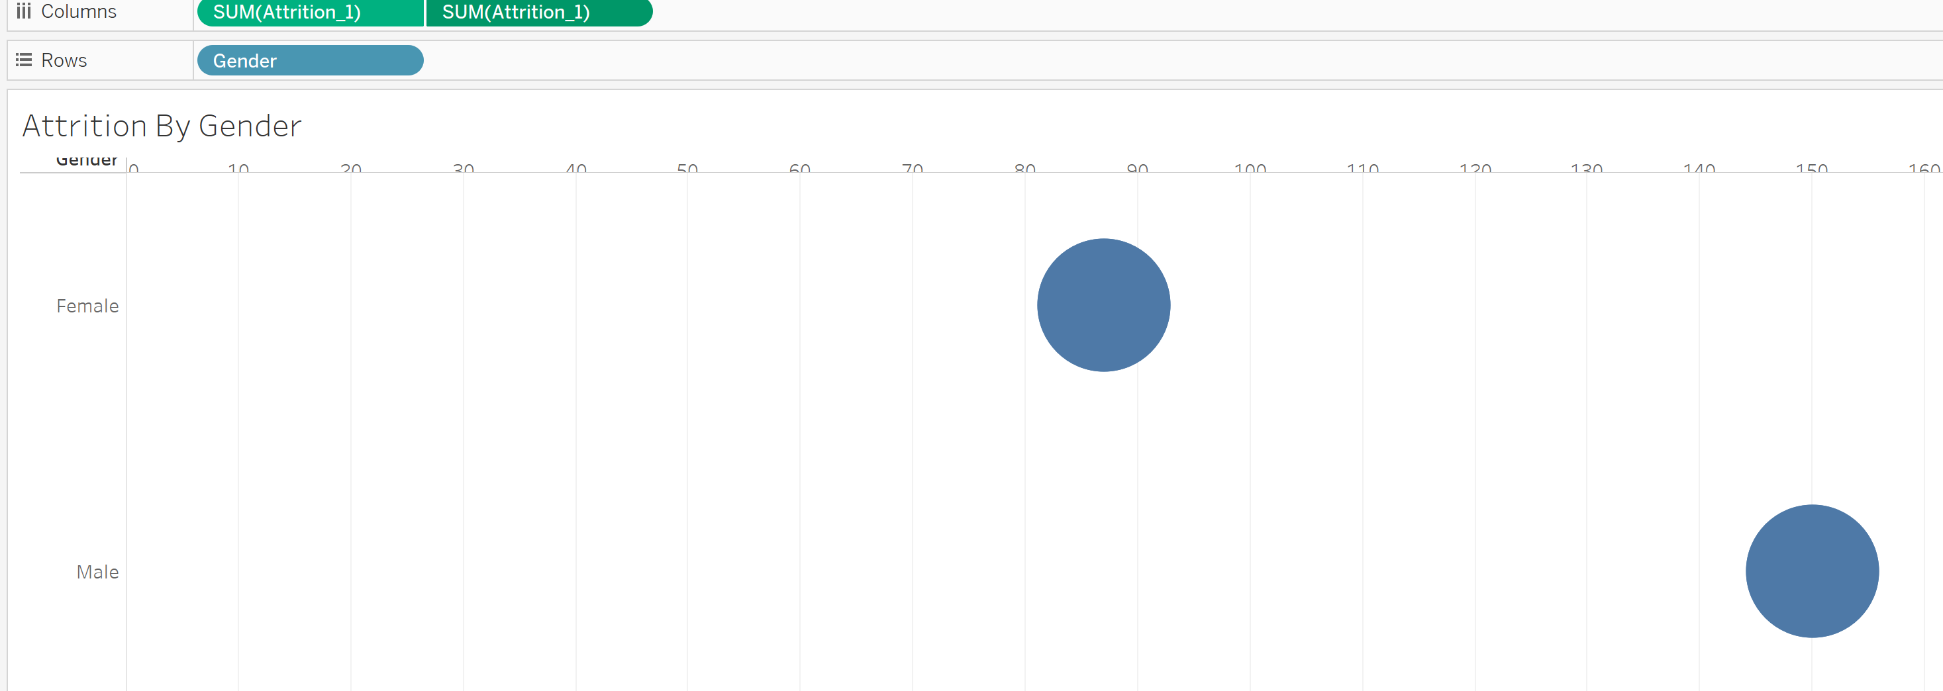



Now it take the corcle for both.

Now I will go into the first one and change it into bar….

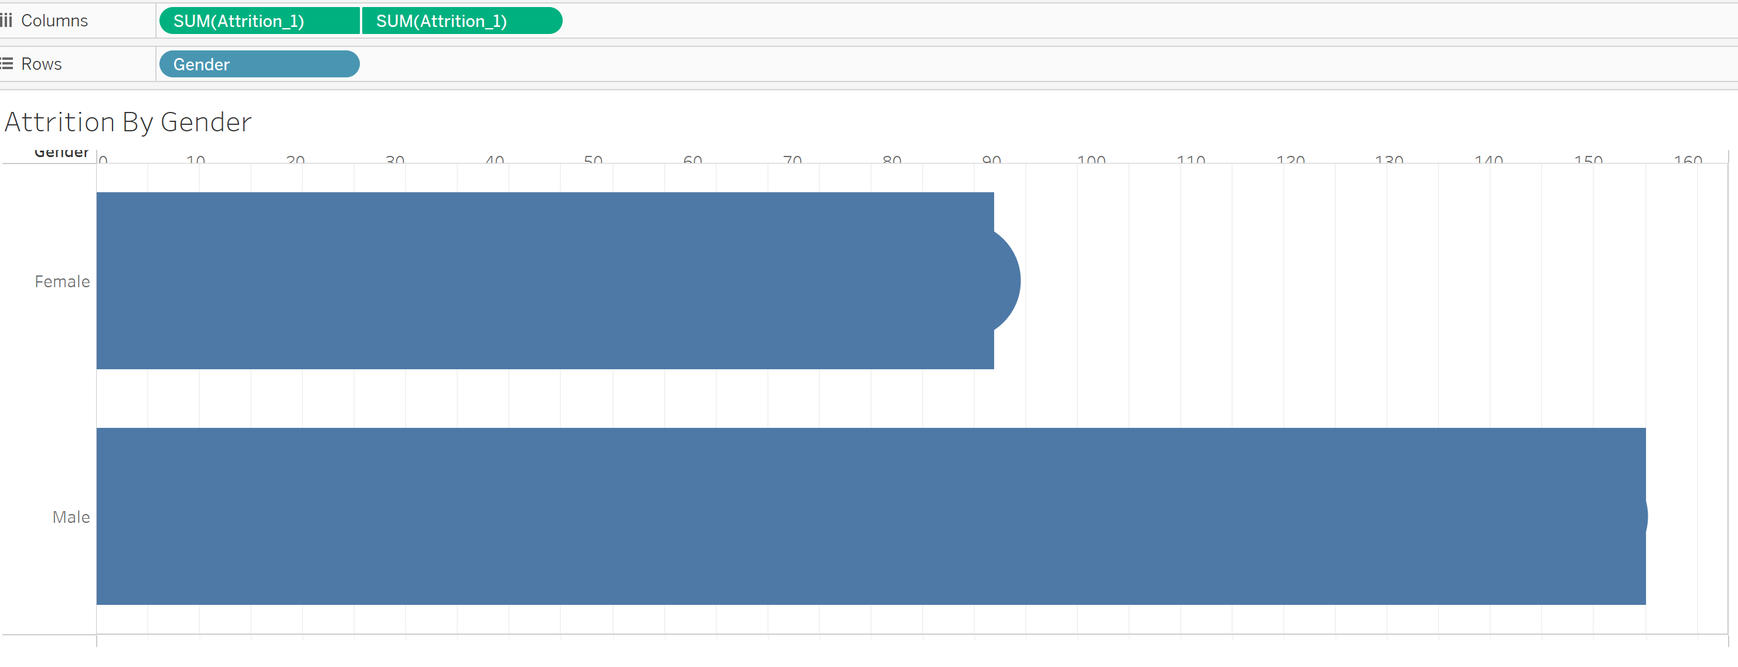



Now we have to synchronize the axis so that the circle shows properly…

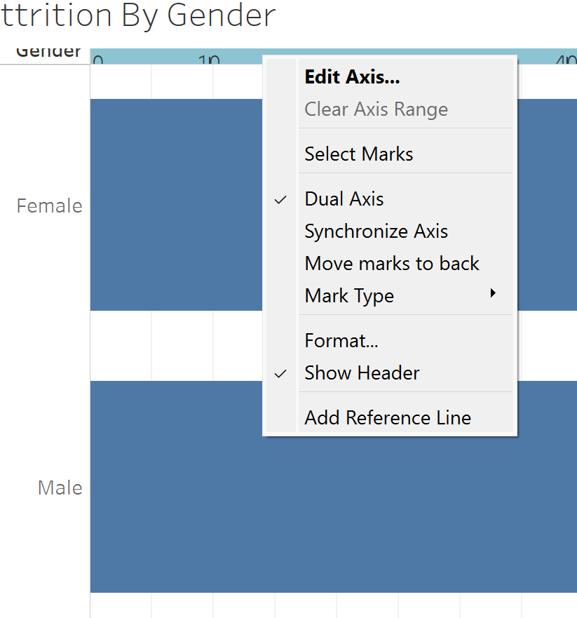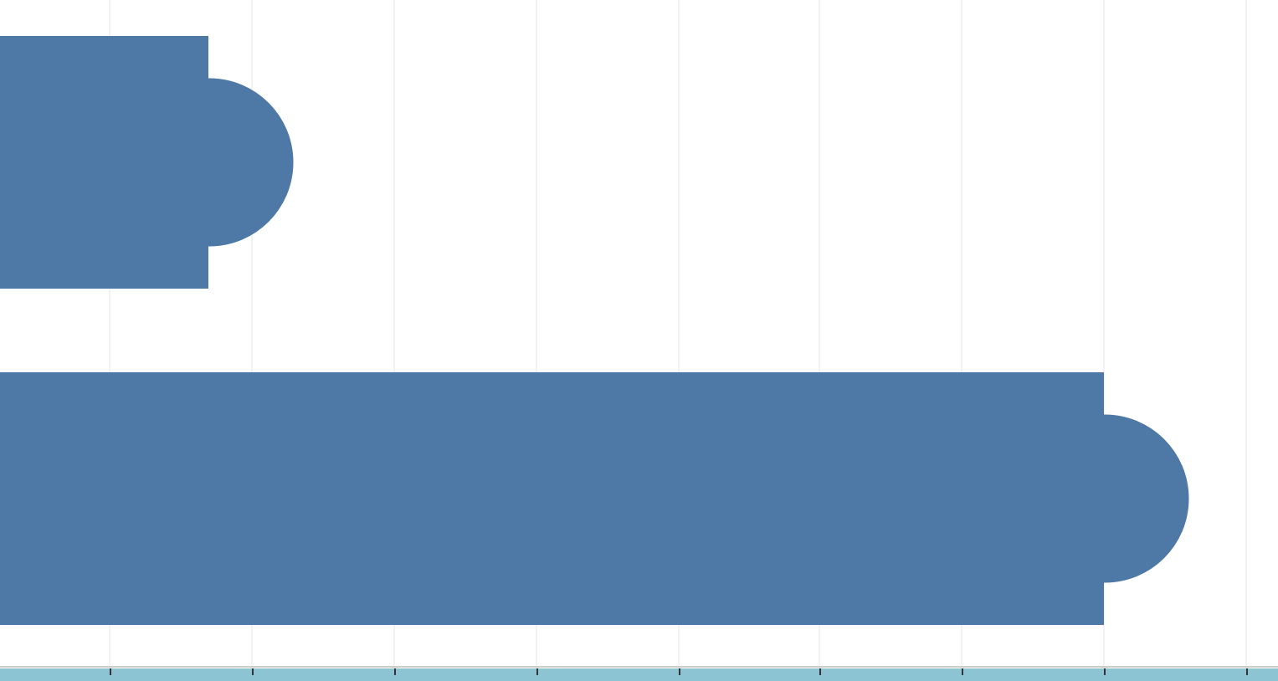



Now it looks fine…

Now we have to make it like lollipop

By increasing and decreasing the size of the bar …

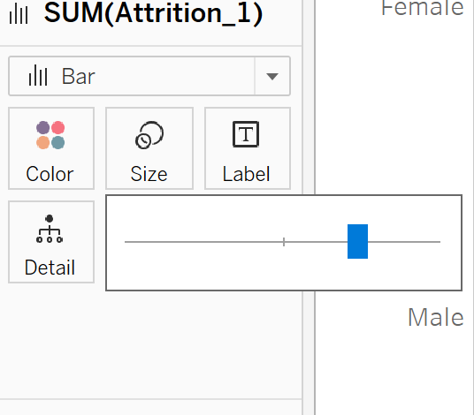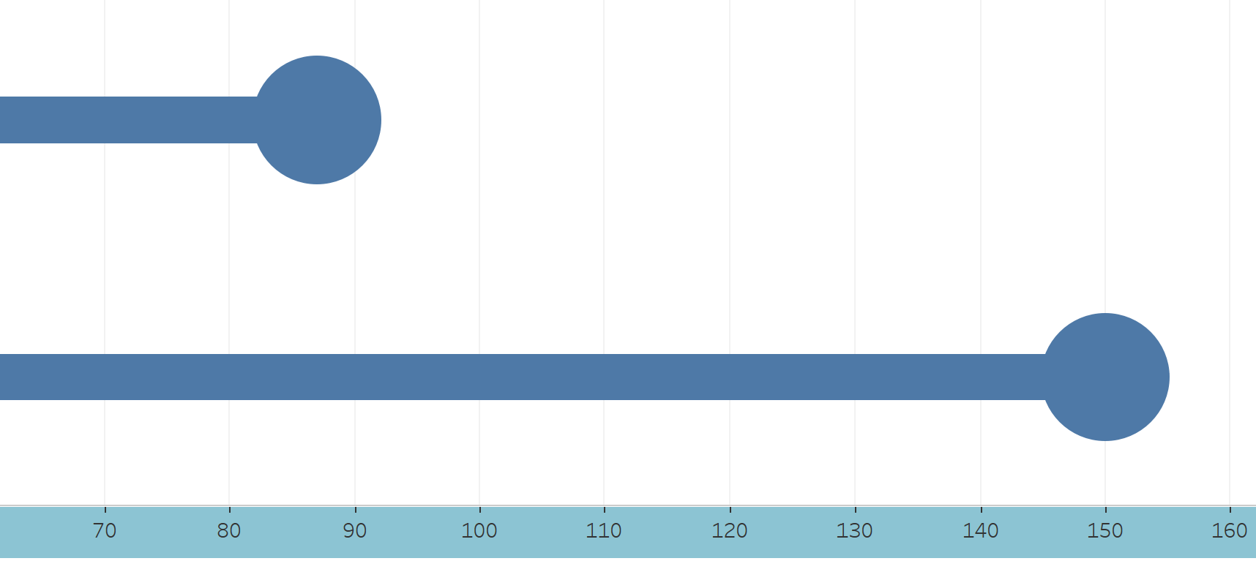



Now lets give the colors to the gender or lollipop

Just pick the column field and put it on the colors card.\

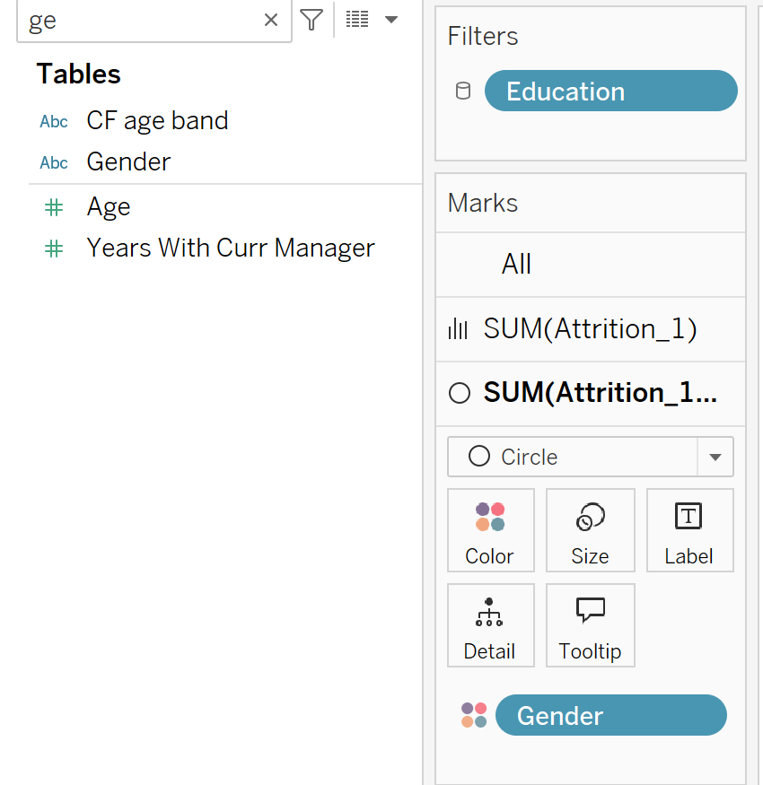Now we can also change the color by just clicking on the edit….



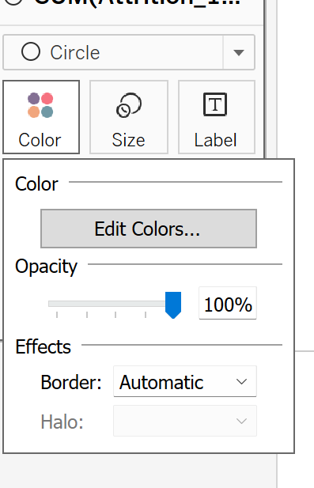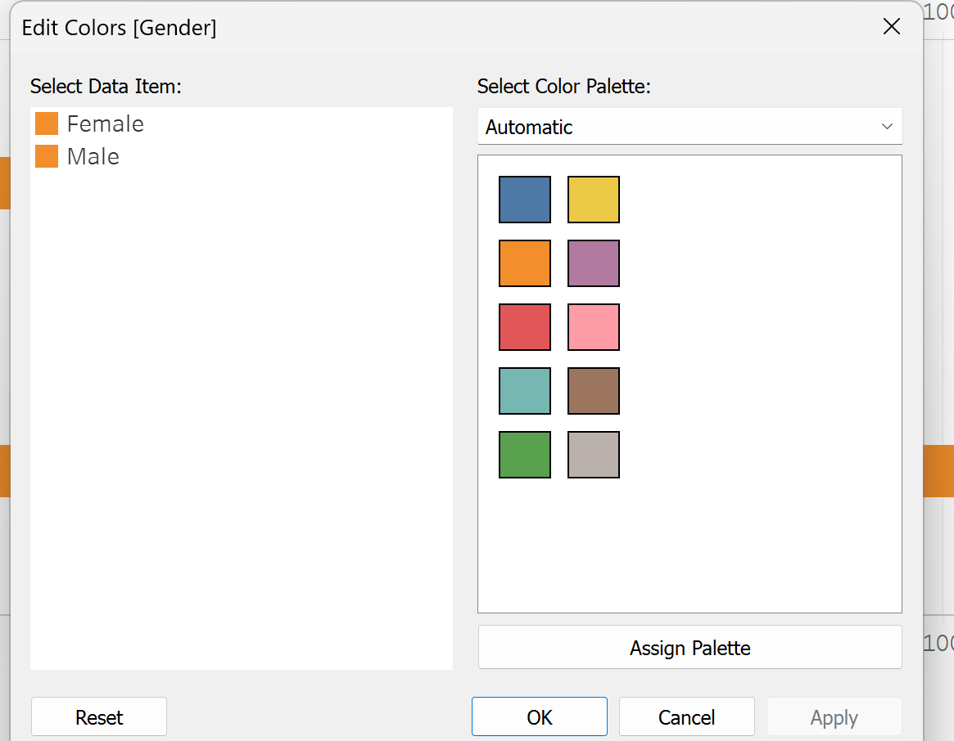



Now next I want the numbers to be displayed on the circle….

Just drag down the instance on the labels…

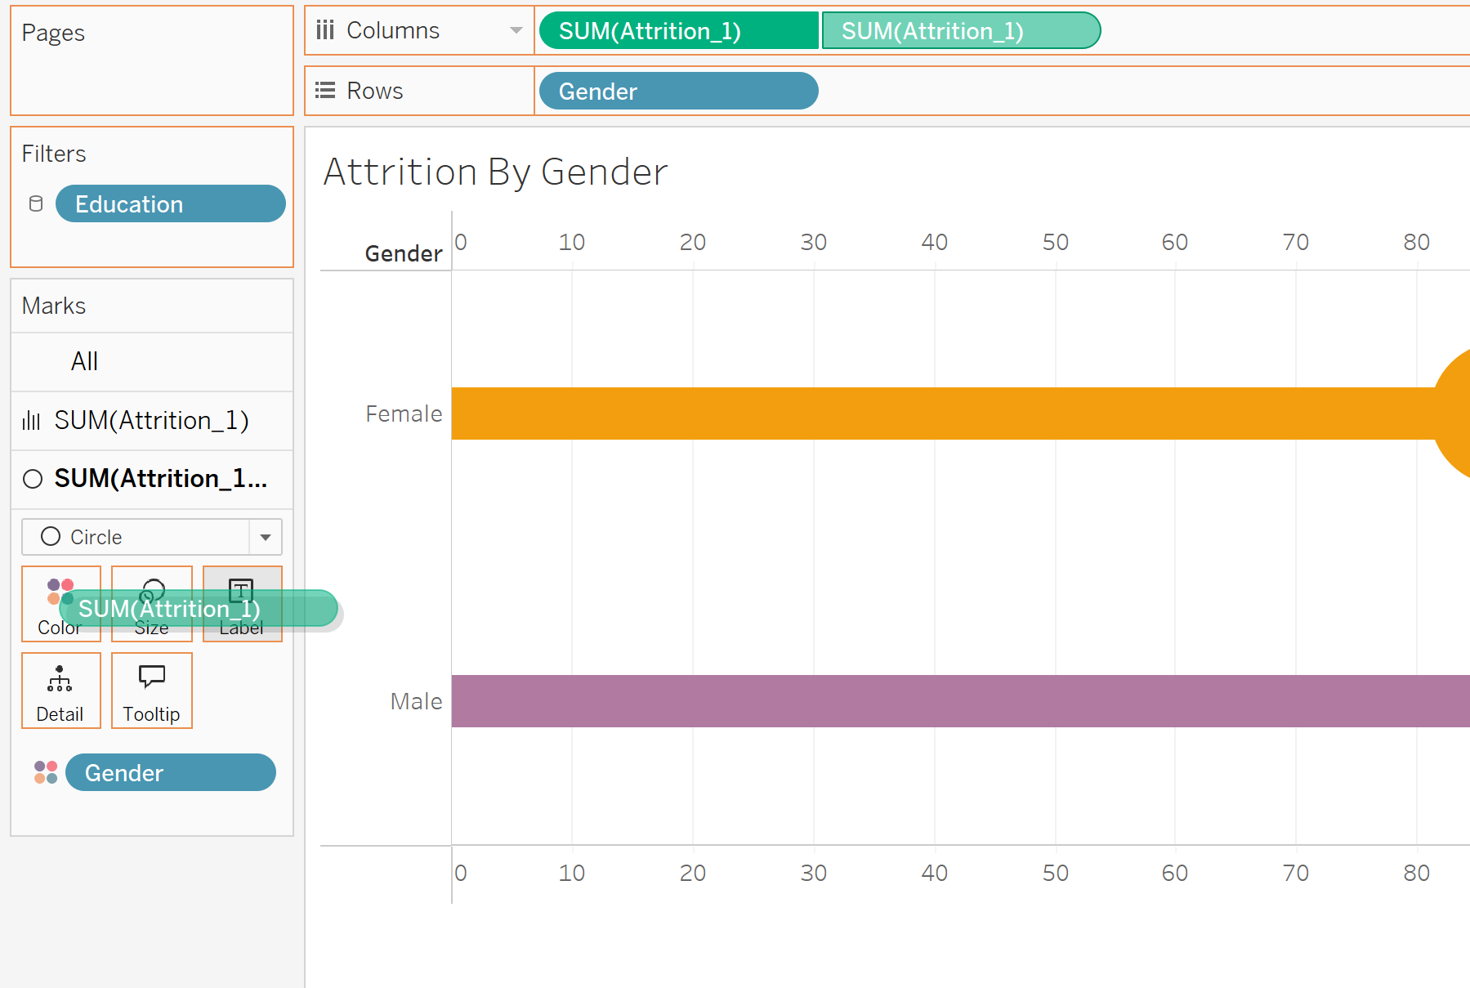



Push the button ctrl when you are doing this .

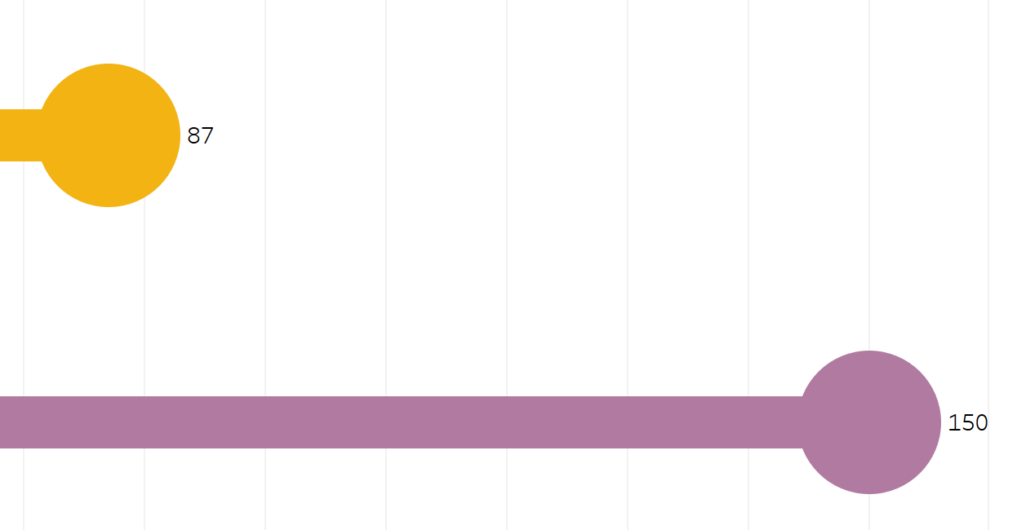



Now I want this in the center….

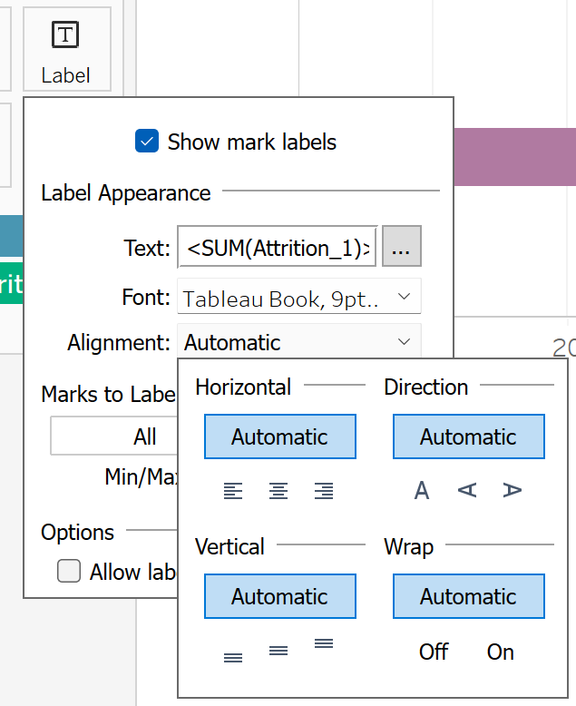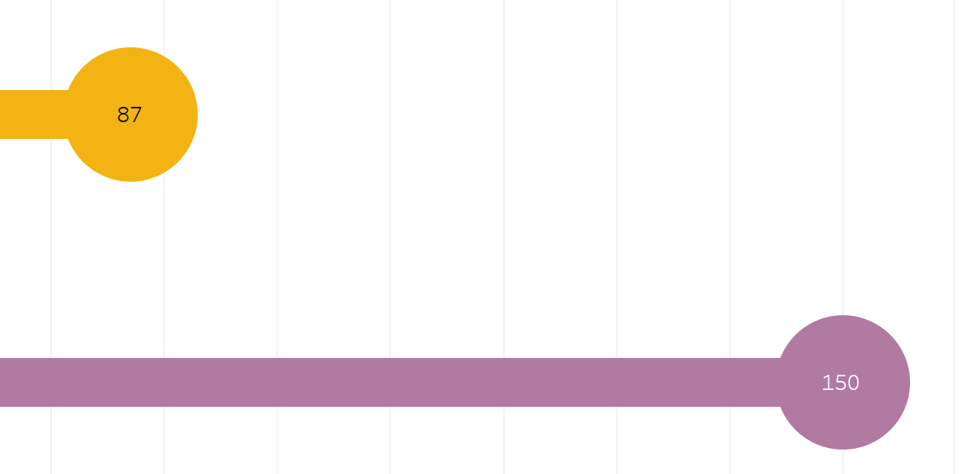



Now we are going to design the “Design of Dash Board Side by Side”:

Its depends upon you how you design it…

New Sheet and name it as Dash Board--🡪 The second sheet….

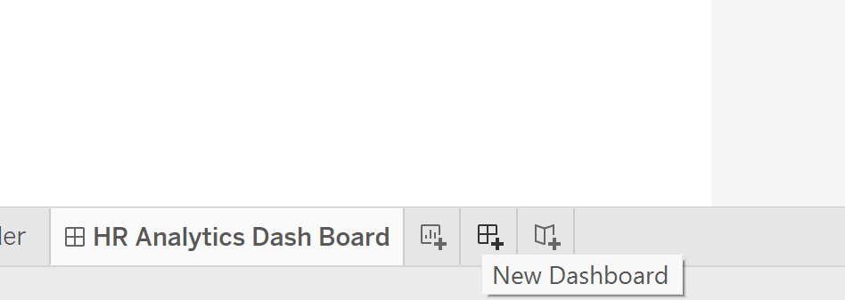



Now you can use the custom size for your dash board…

So you can change the size --🡪

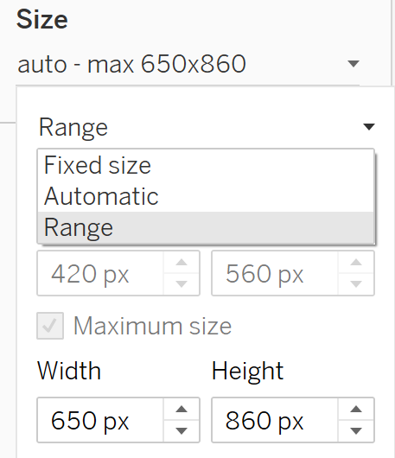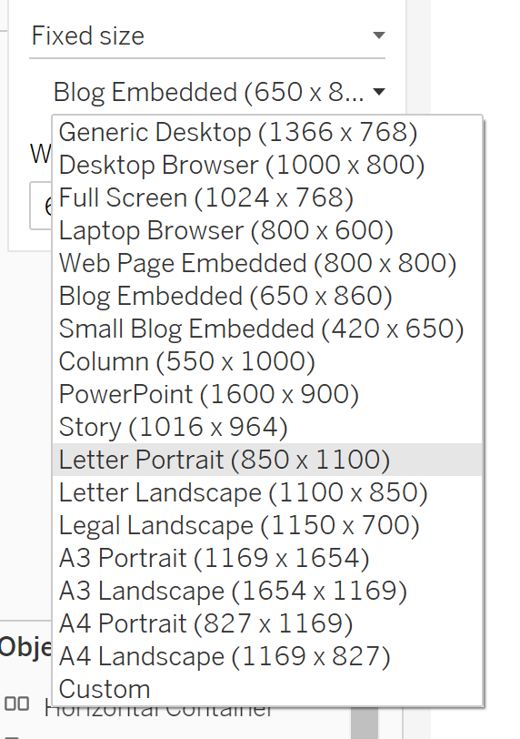Choose desktop Browser



Or custom size….

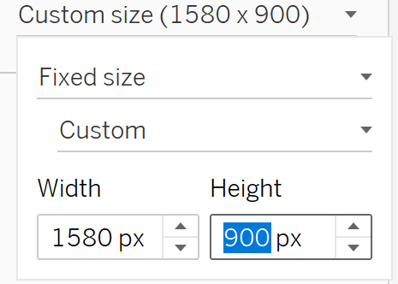



It depends upon your laptop resolution…..

Now we are using some custom shapes or wallpaper or background etc….

It depends upon you wanna you design it in Canva or power point….

Powerpoint ---🡪

Converting it into Image just save it as .png….

Now we are going to import the png image into the tableau….

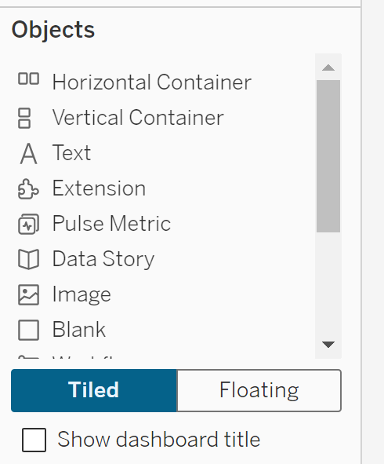



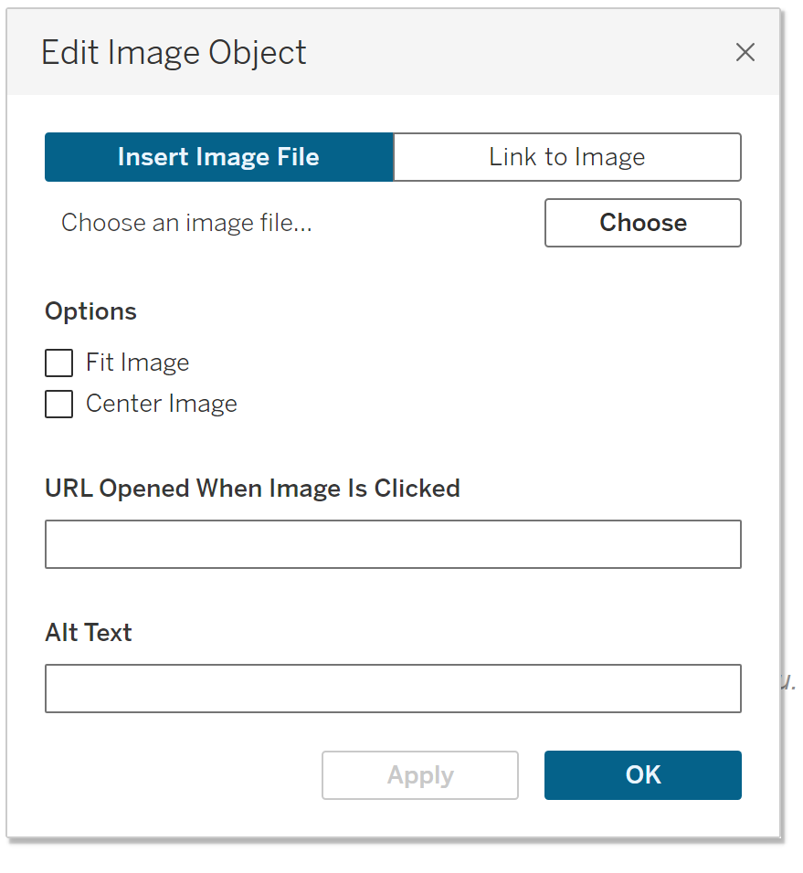



Choose the image and then click okay and apply/…..

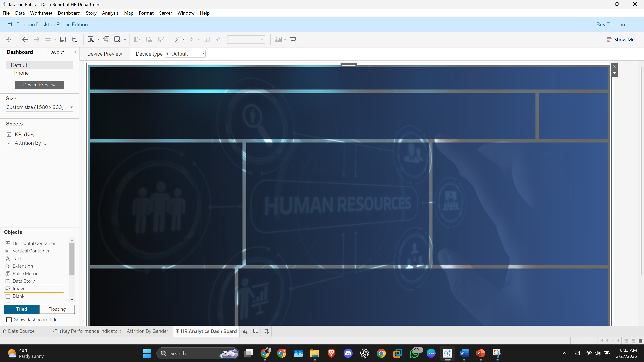

You can also check it out in different devices…





In future we will place all the sheets in the dashboard….

Make sure to use the floating option coz using floating we can move our Charts or graphs and all from one place to other easily…

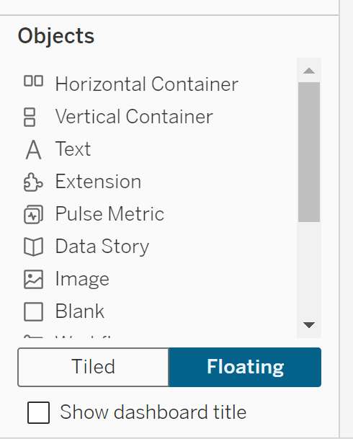



Now lets place the KPI and Gender sheet on the dash board…

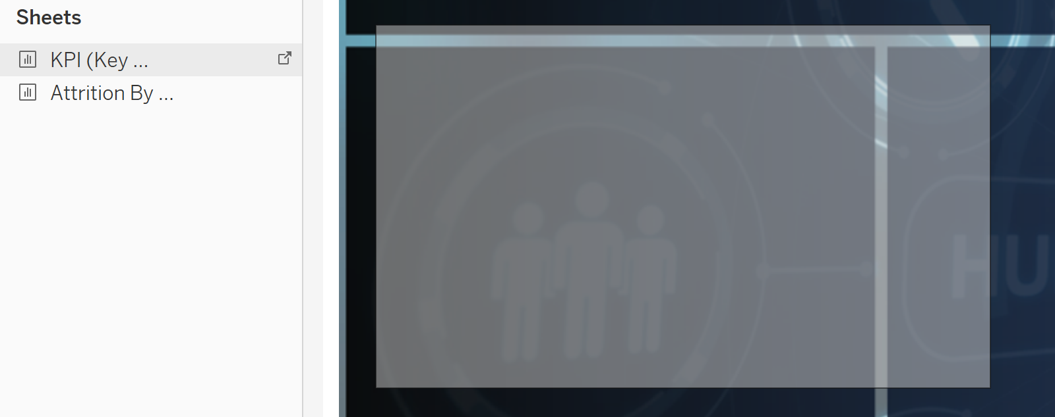



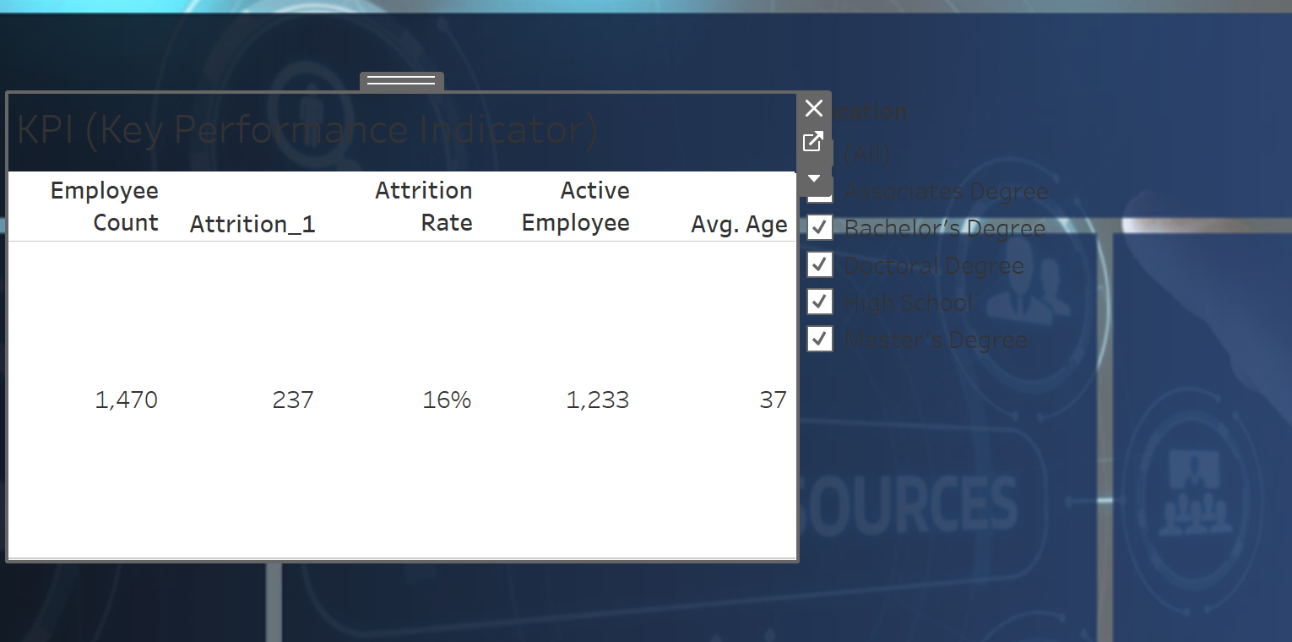



You can hide anything you want…right click and hide it…

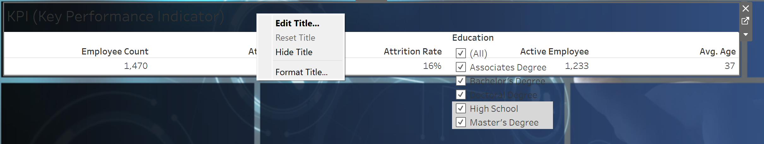



Also remove the filter for now…

Now lets do some formatting of the chart…

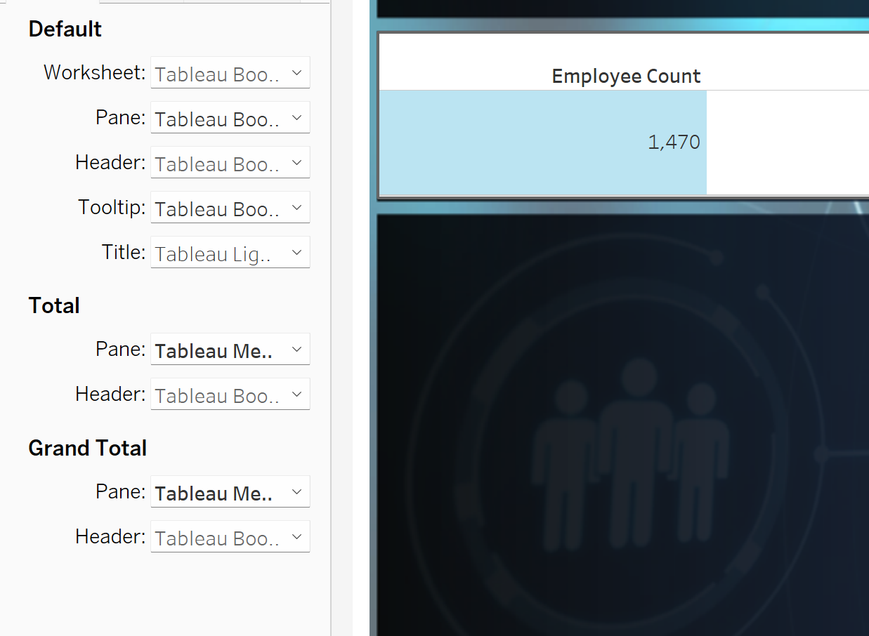

Right click on the chart then the pane will open and so some editing…

Font, size, etc

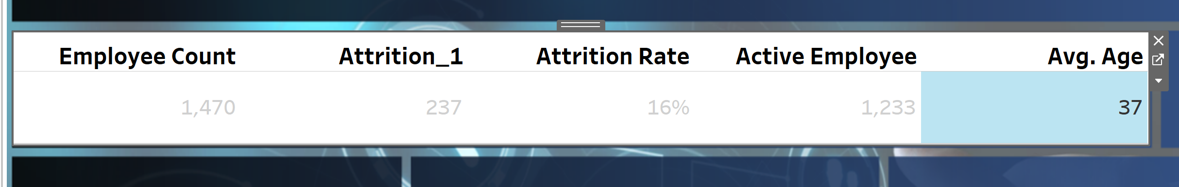



Now let remove the background of the chart….

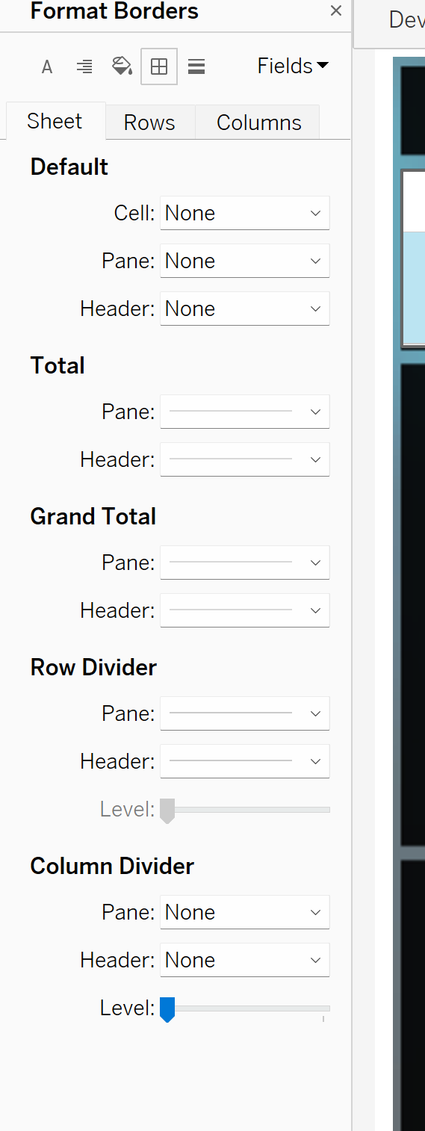shading option now use it and do changes…



First make it as “None” for the color…

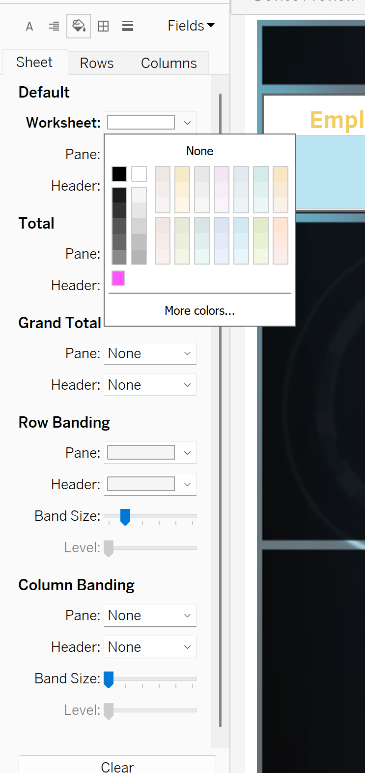



Now you can remove lines increasing the font size, b=remove back ground, etc…

Now you can make the digits as center bu going back to your KPI Sheet…

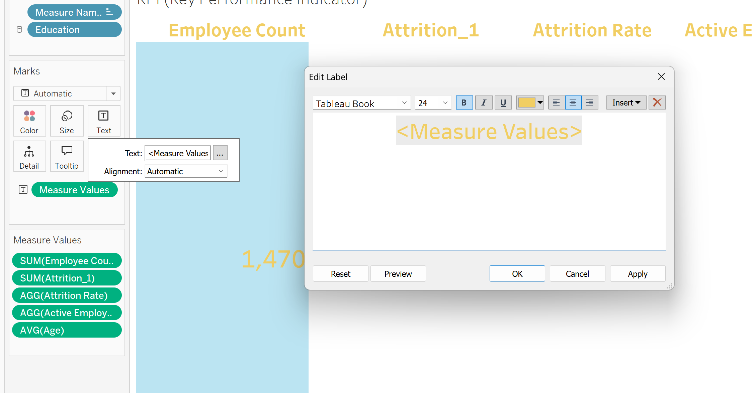

Now move the Gender chart and place it on the dash board…

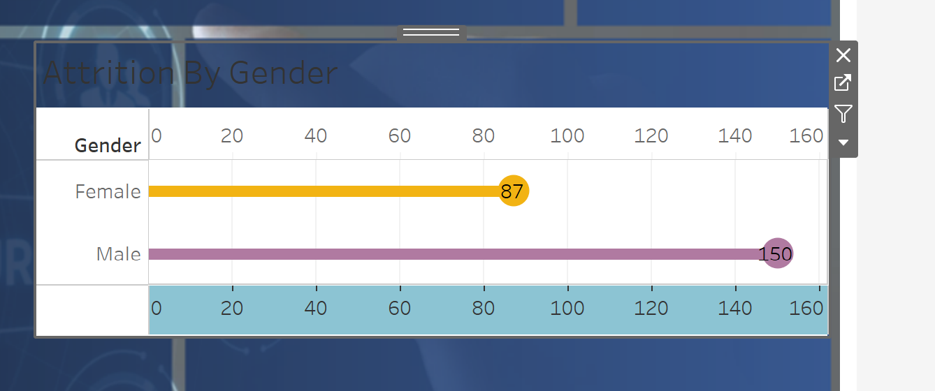



To get rid of the heade and footer and also making the header visible edit it as font style….

Show header

Show footer

Double click for editing…

Making the PIE Chart:

Now for making the pie chart I will create the new worksheet and then rename it as “Department Wise Attrition”

After that I will put the department Column and put it into Colors.

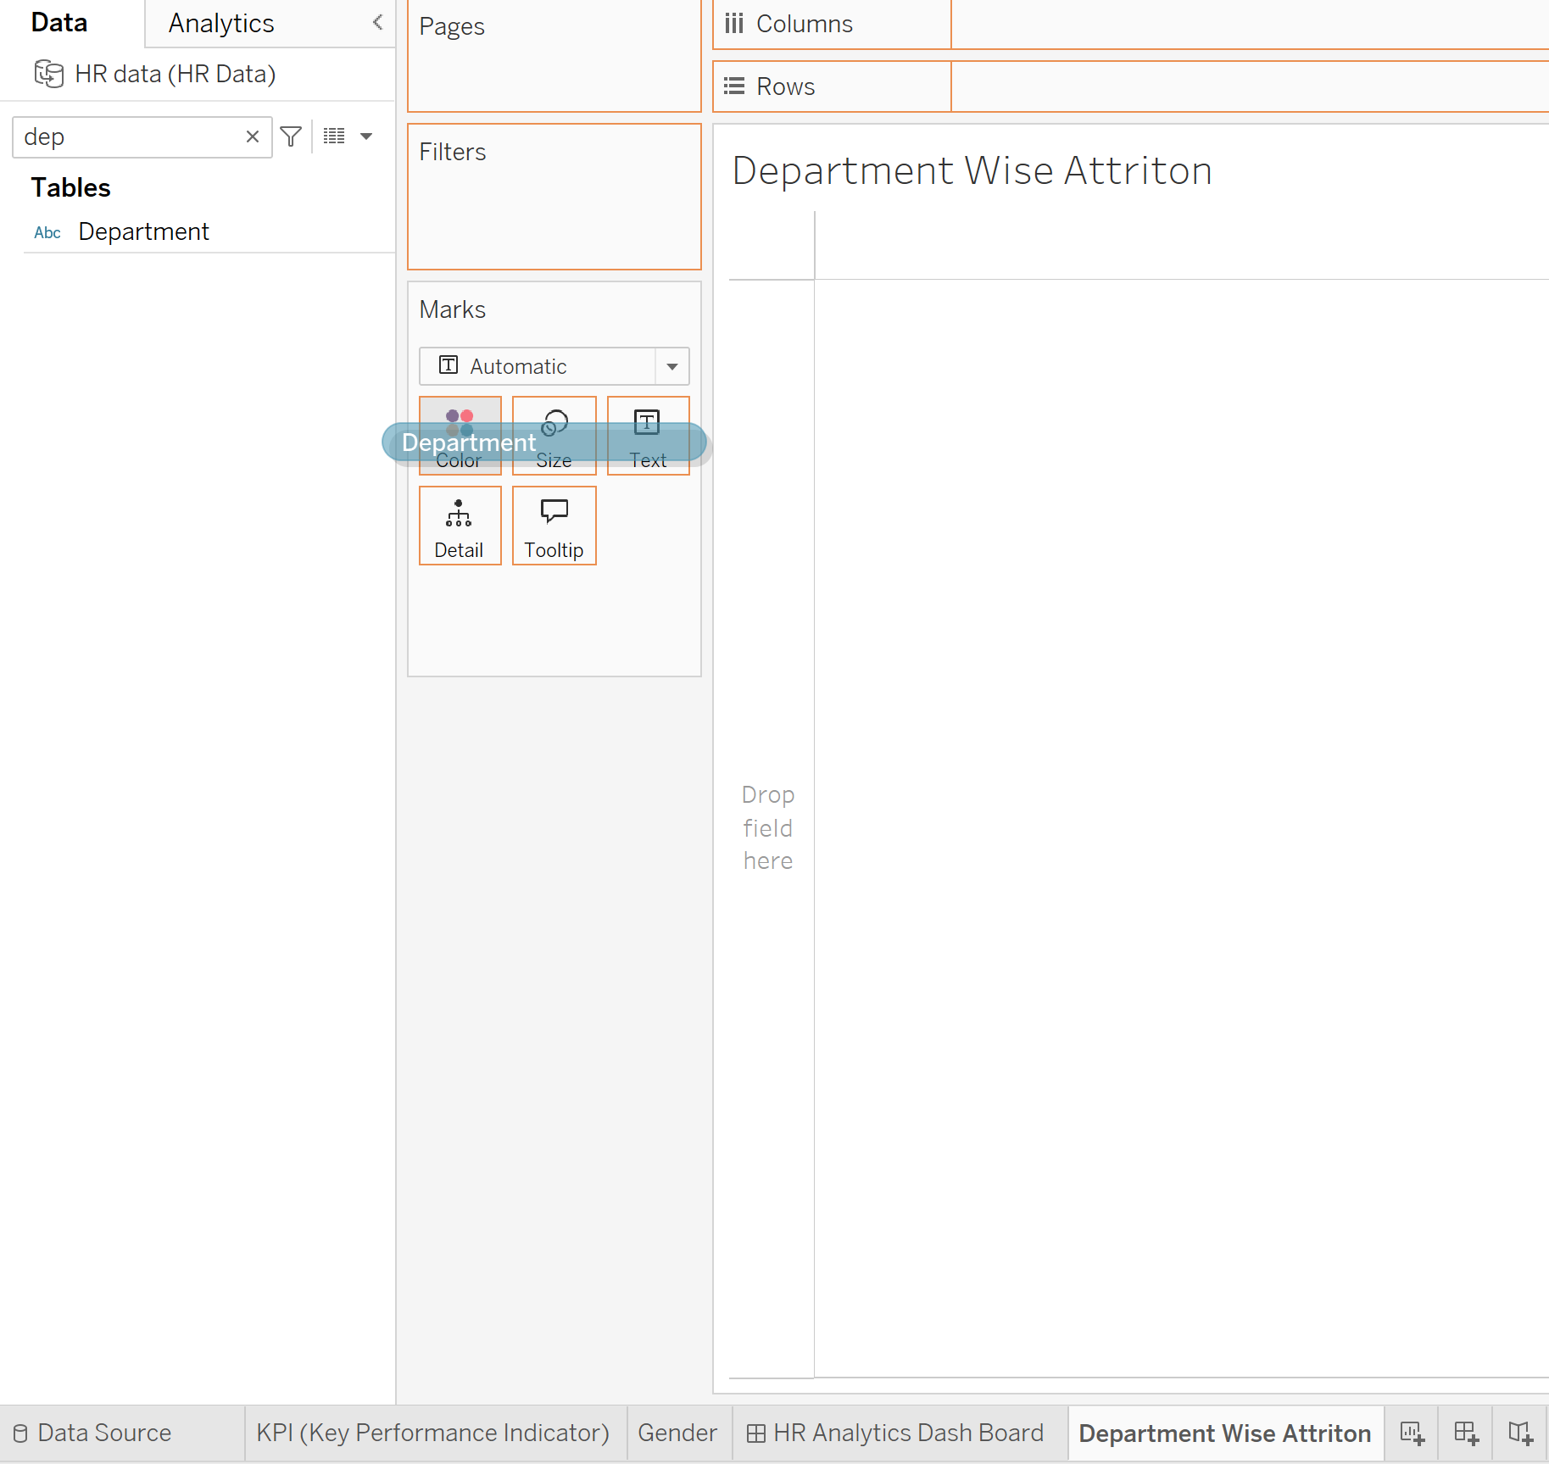



After that change the Shape of the chart by using the following:

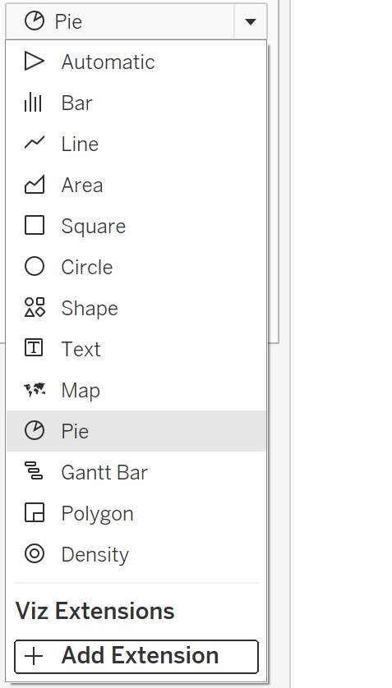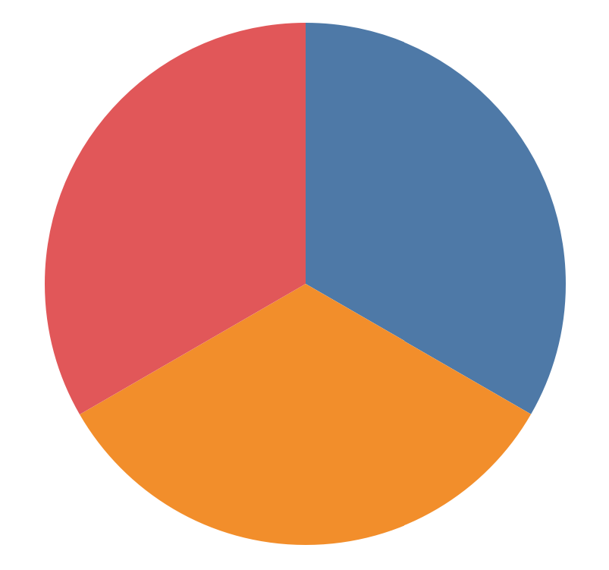



But it gives the equal slice for each department.

Now for making it effective we will put the other column that is attrition count and put it on to the angle…..

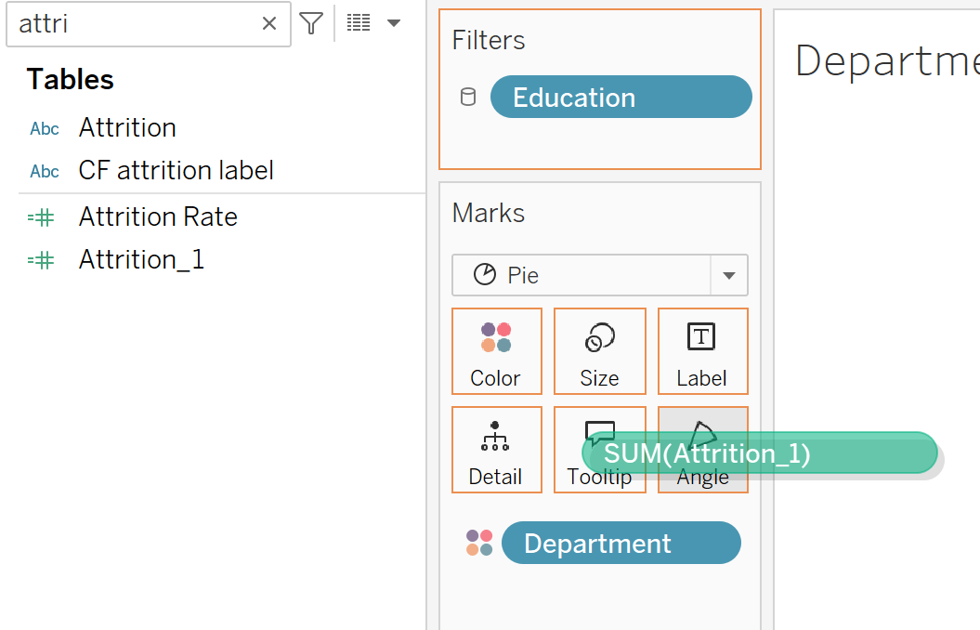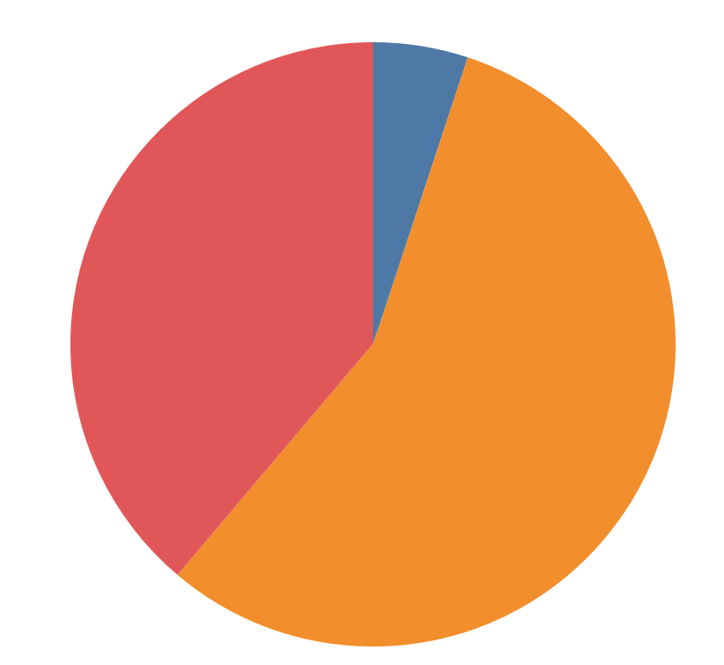



Change the color according to your background of the dash board….

Now we have to label the chart….

For that we will Check the attrition_1 and drag it on the Label in card…

Then the label will be appearing

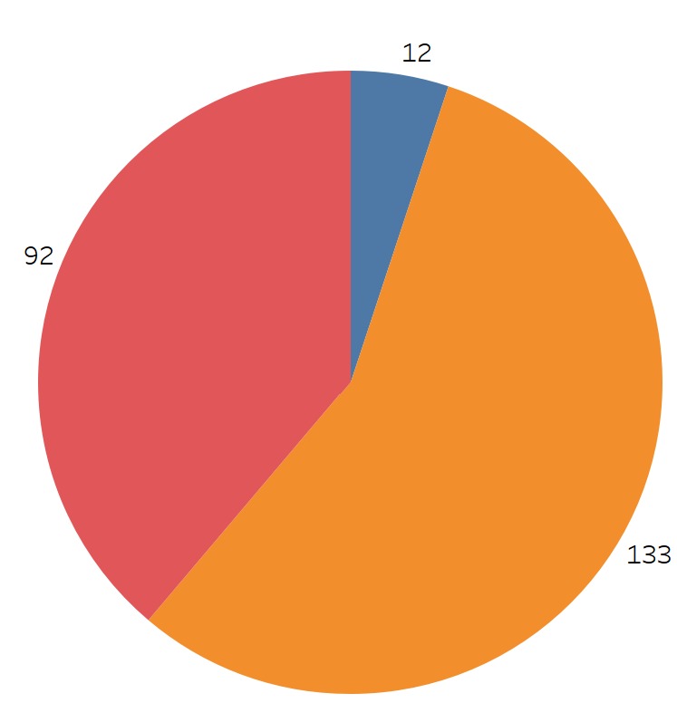

To show it in the form of percentage then click right on the attrition_1 and in quick calculation change it into whatever you want…”Click on the Percent of Total

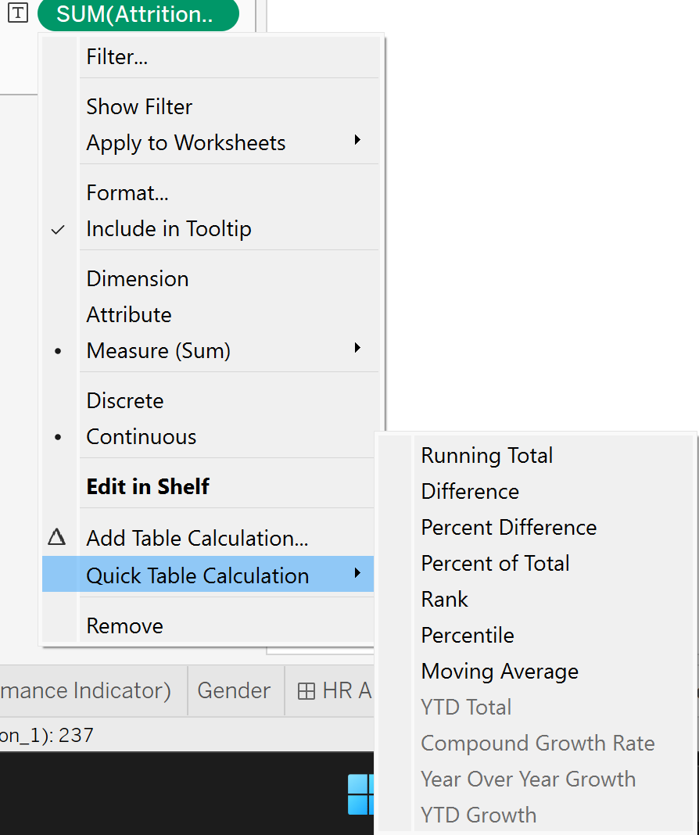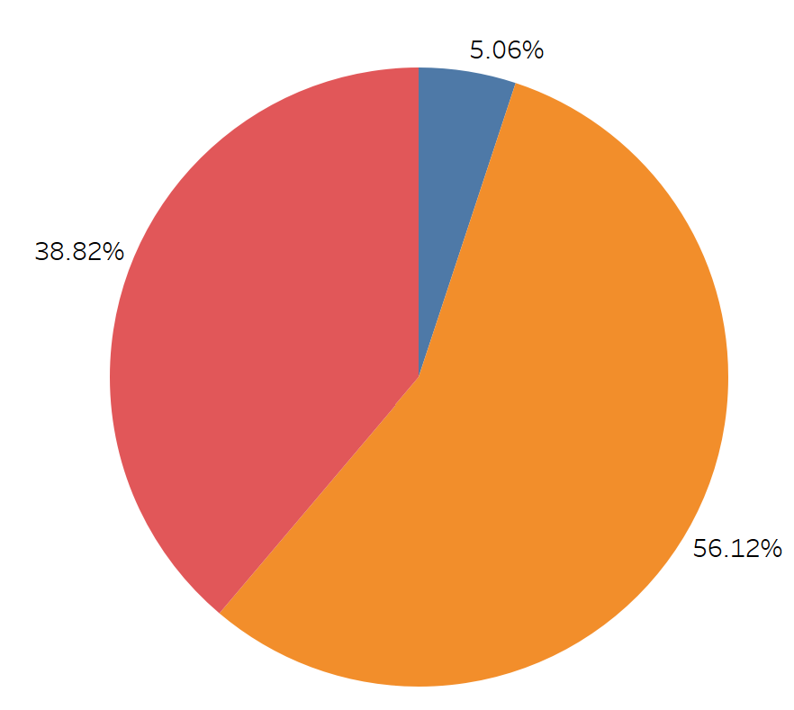



In order to get the total number also then you have to press the CTRL and then drag the Angle from the card on the label then you will get the number also. By changing the style of the label you have to just click on the label and edit it accordingly.

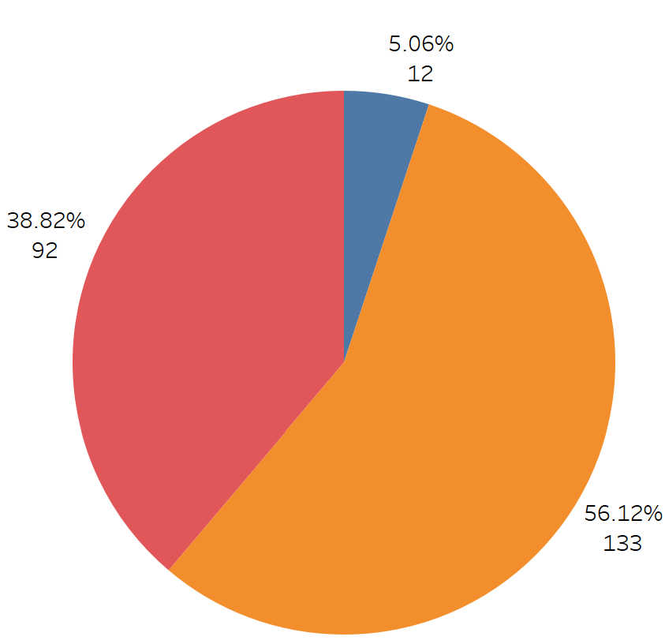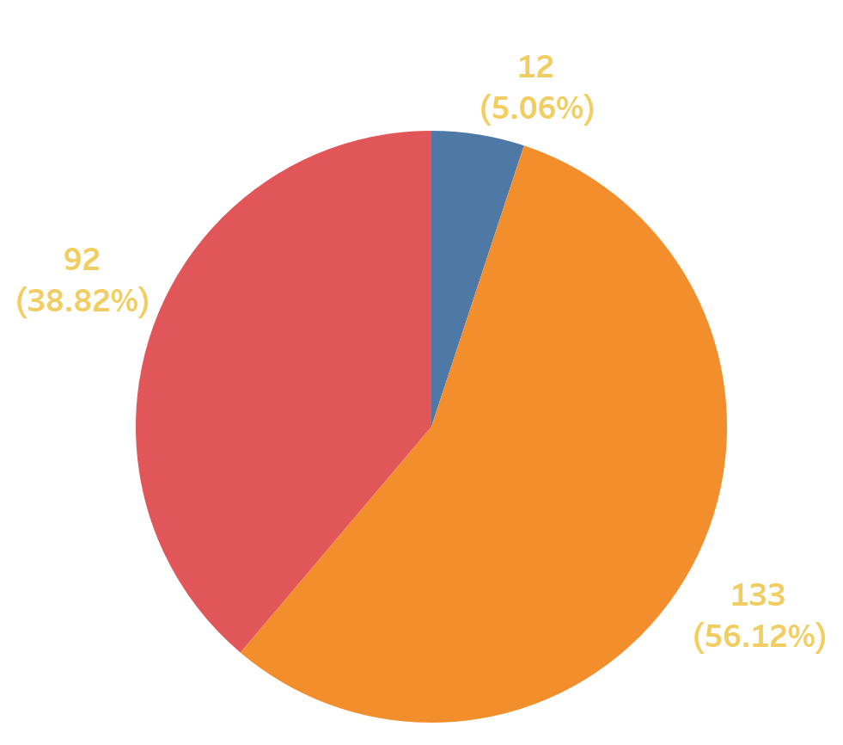

Now place the shape on the dash board….

Change the color of the legends also the title of the chart etc..

To change the color of the legend you have to just click on format and then on “All legend option” and edit it according t your wish…

Now we are going to make the “Bar Chart” and named it as “No of Employee by Age Group”

For Bar Chart first we have to create the “Bin”

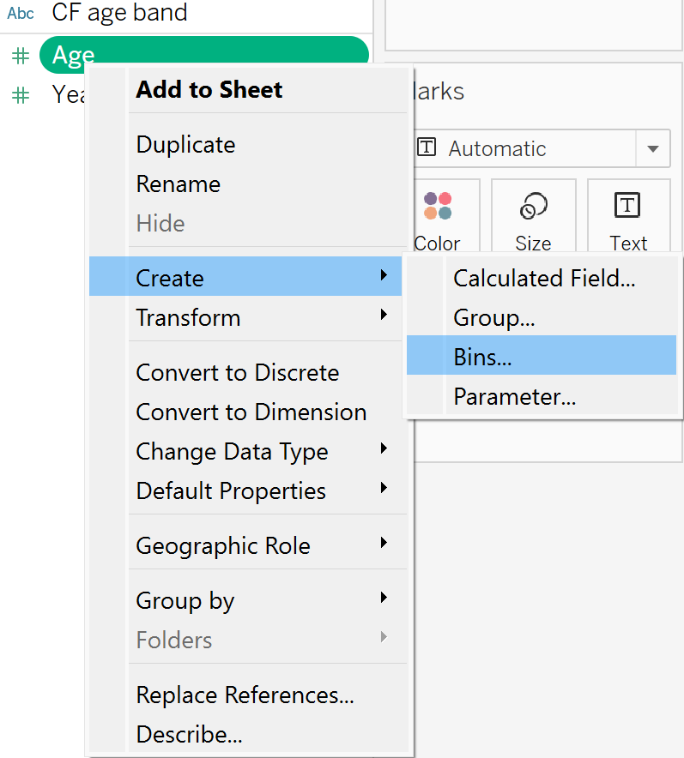



As the age is not in decimal so we have to make it as integer format and then we have to create the new parameter….

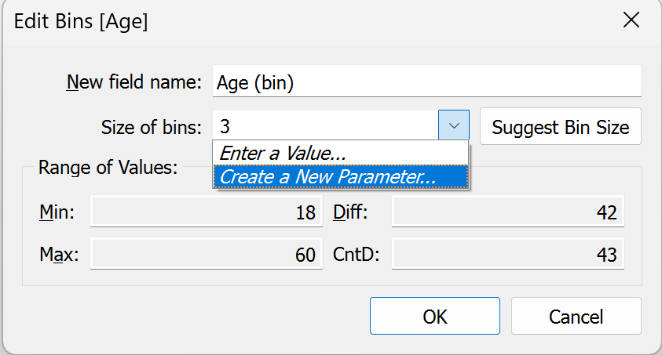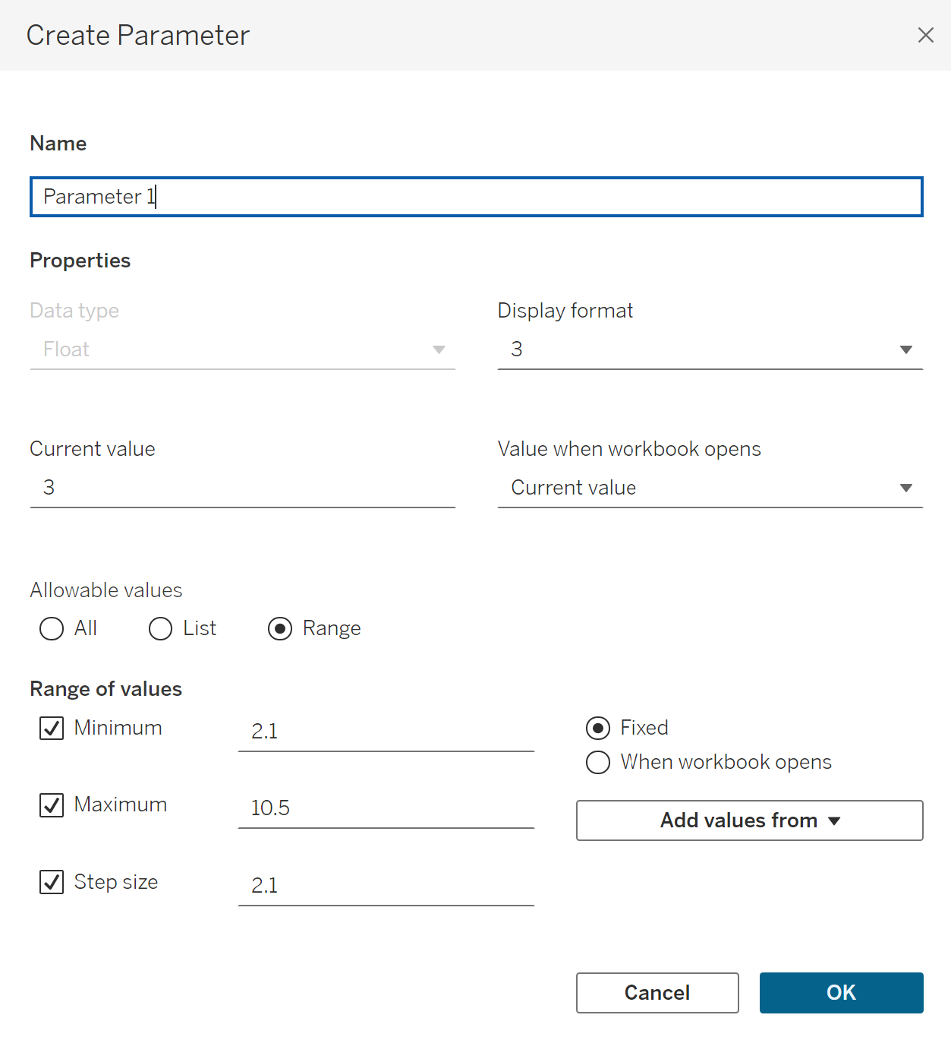



In this now we will make some changes…

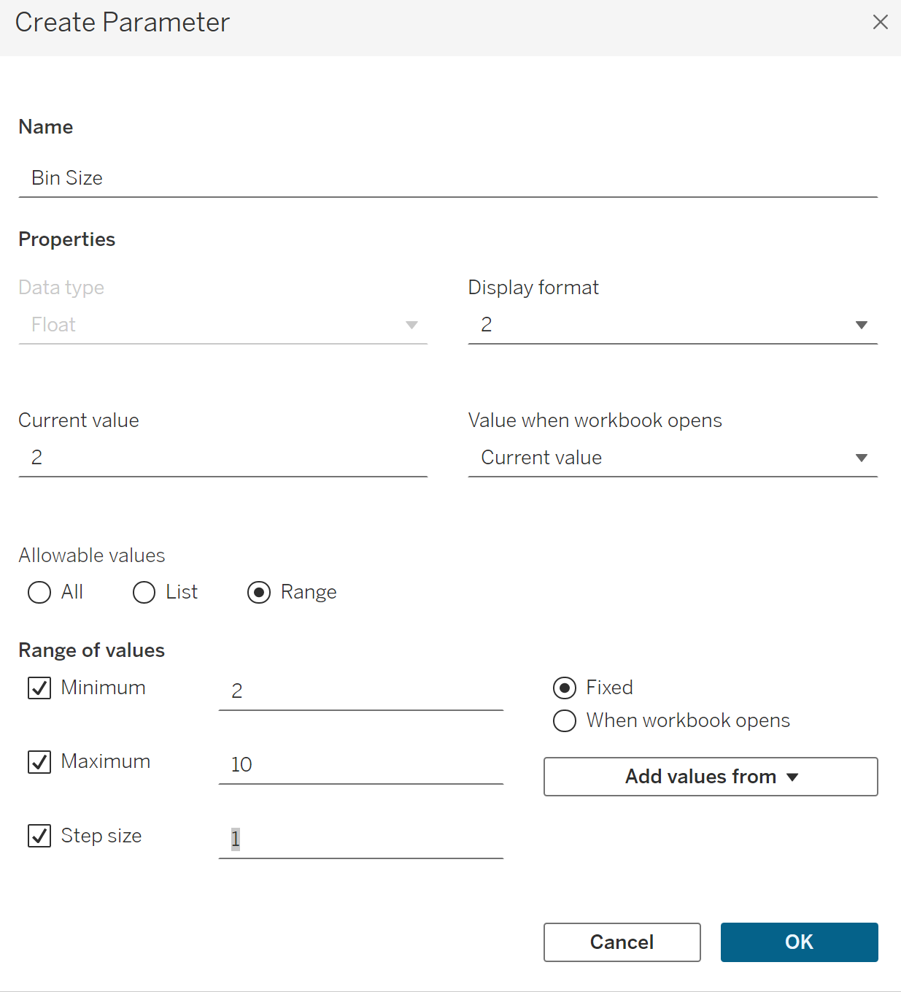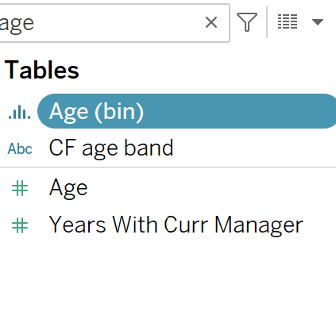



It will be included in the new parameter portion…

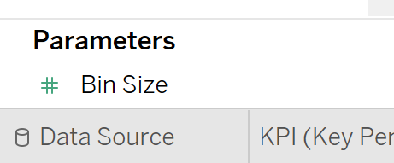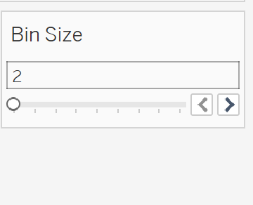



Now take the Age (bin) and place it in the column or Row…

Now the default size of the age is 3 we can check it by click on the “show parameter” and we can change it using the bar….

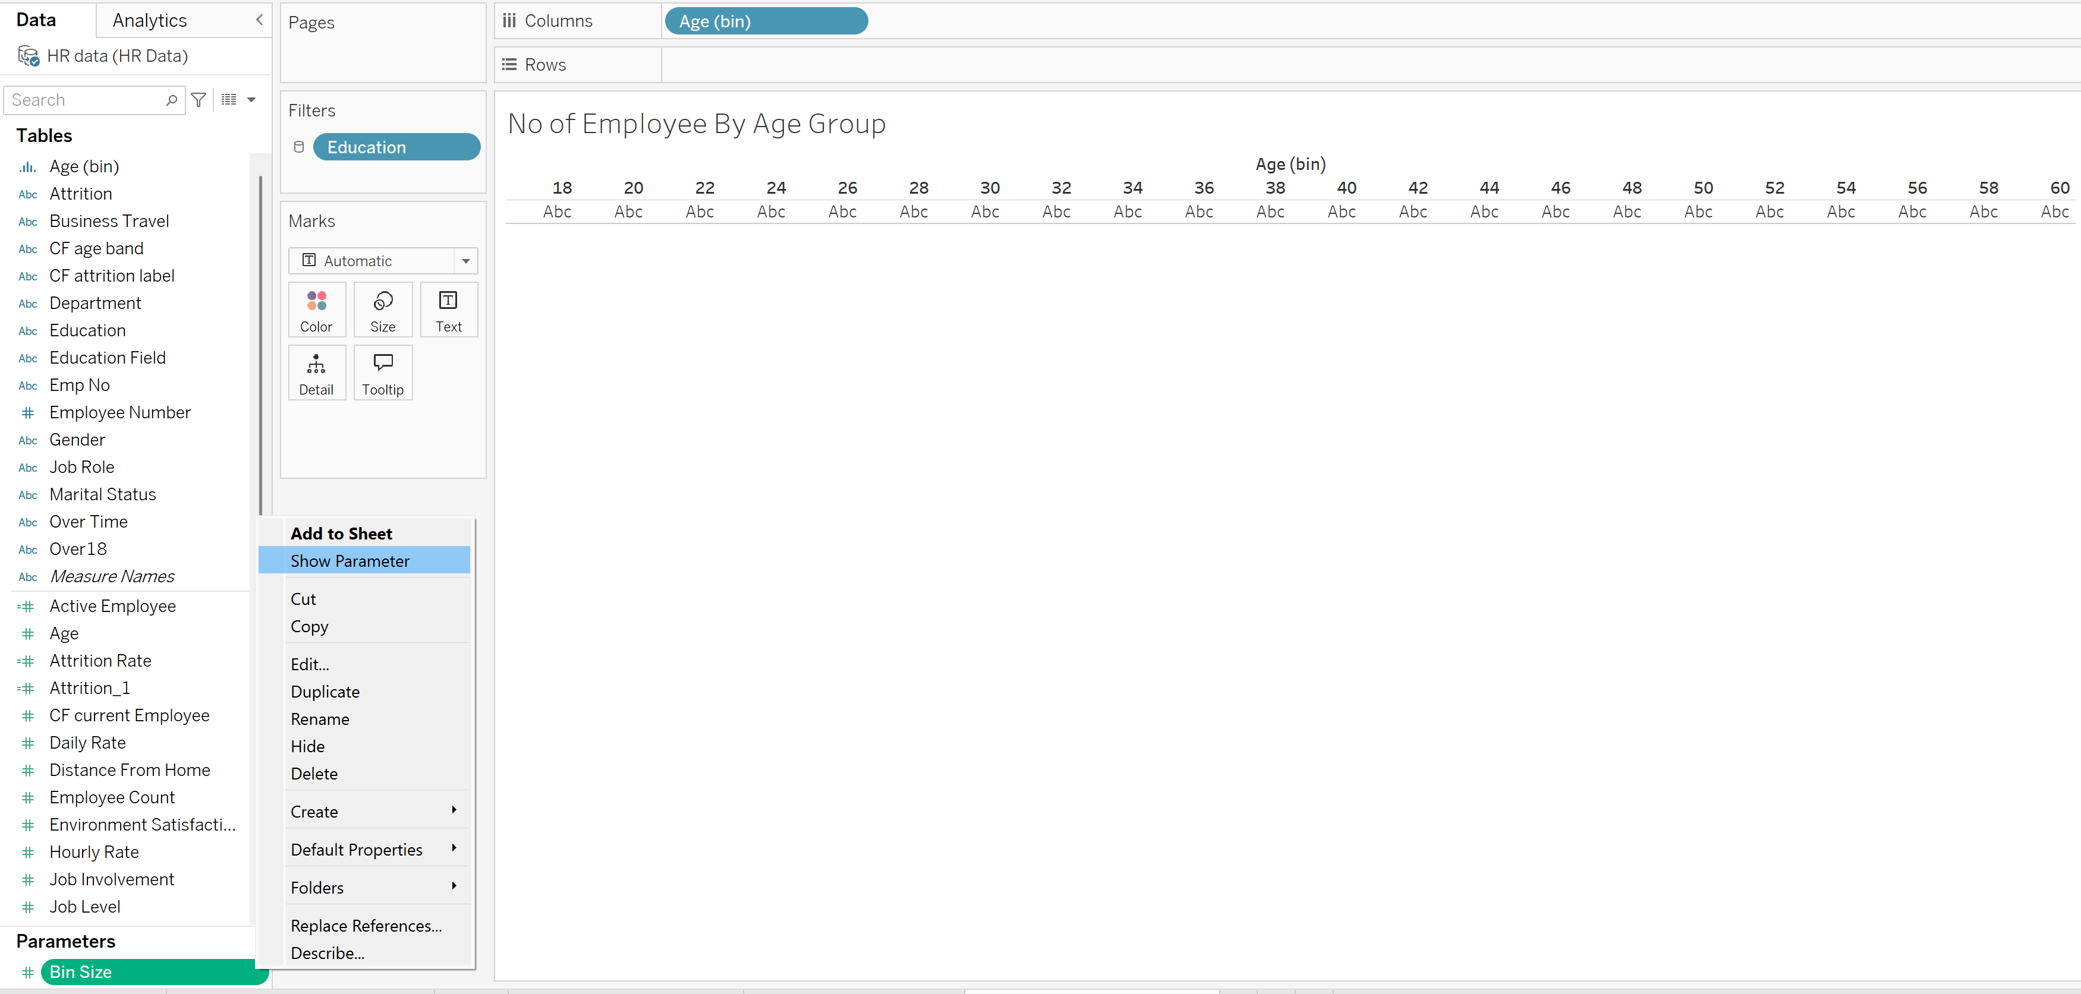

Now we have to place the “Employee Count” in the Row and the bar chart will appear…

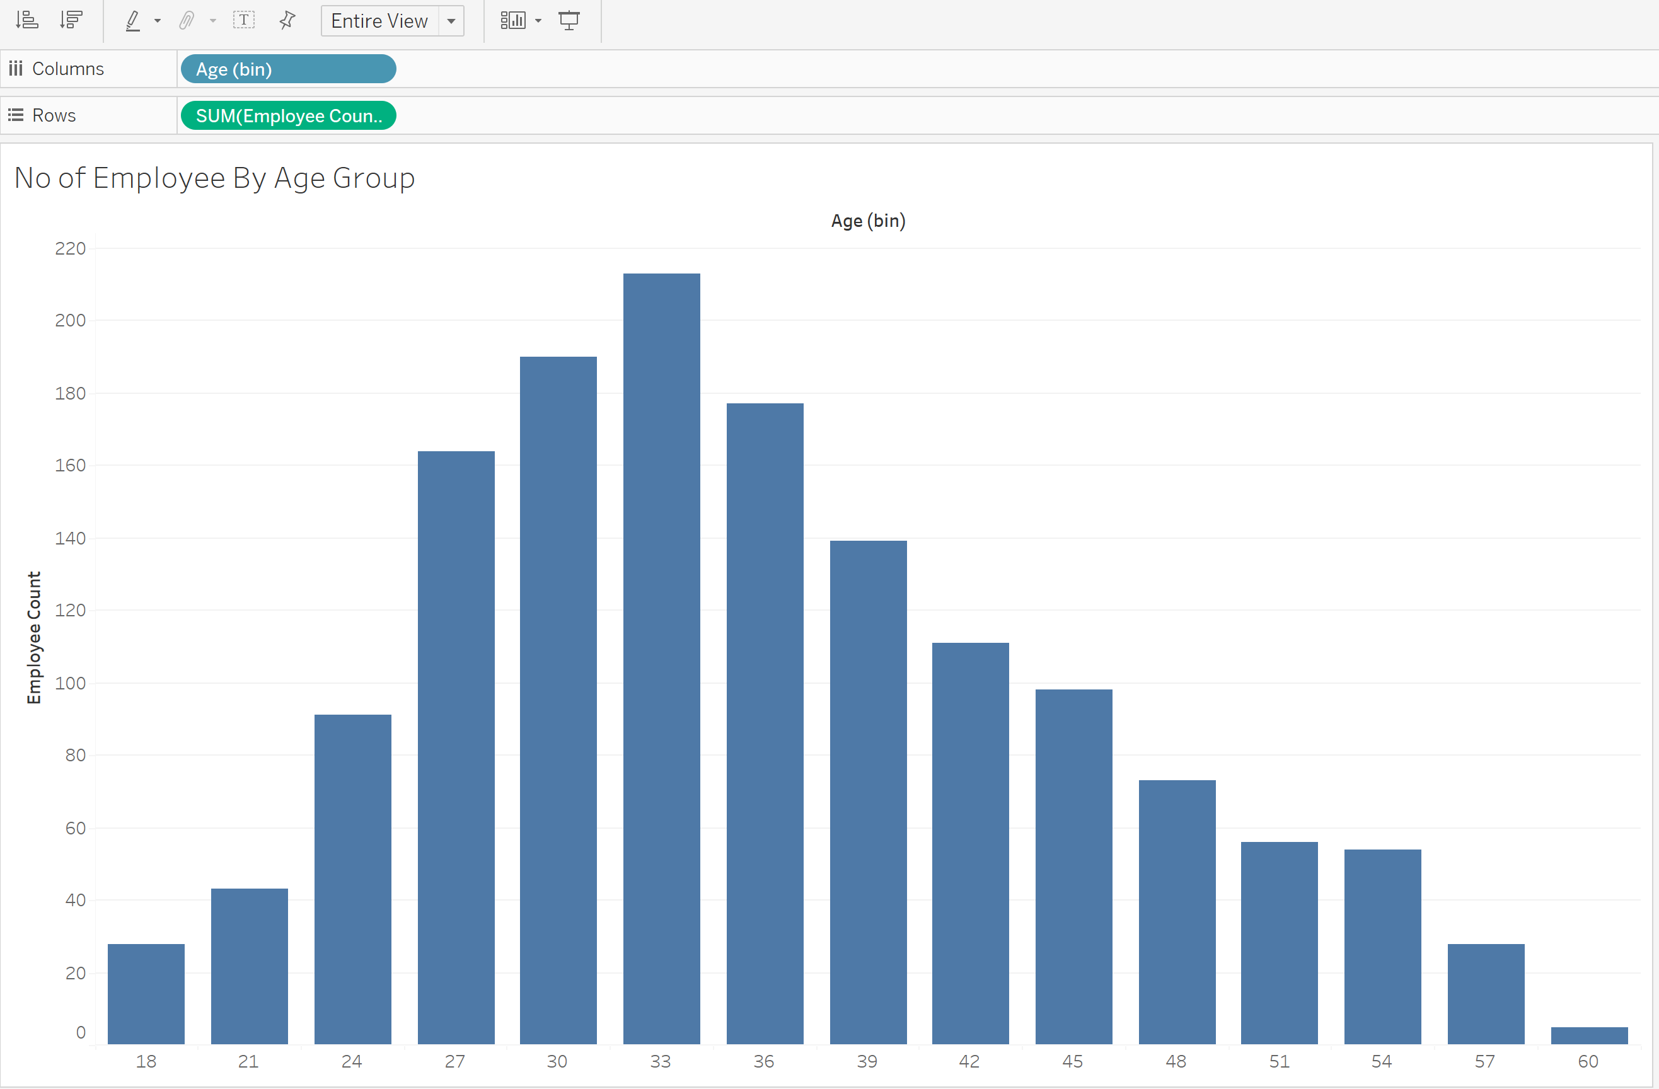

Now in order to appear the Bar chart along with the number on above we have to drag the employee count on label.

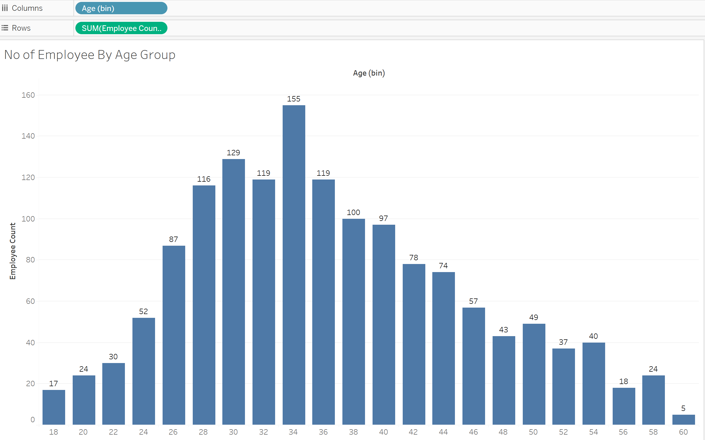



Now place the Bar chart on the Dash board and do editing accordingly.

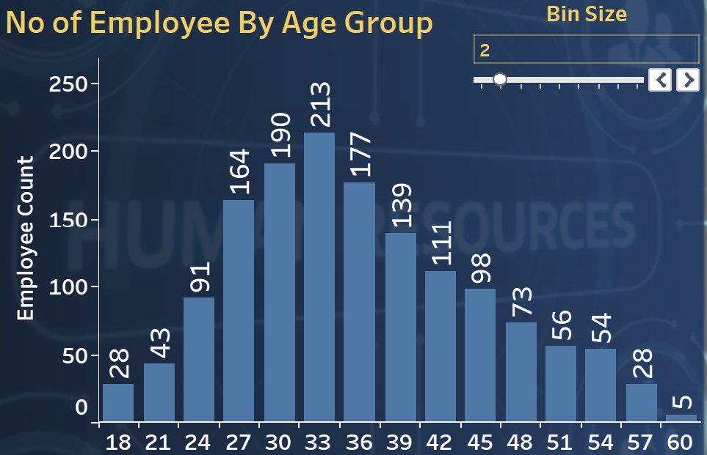

Now its turn to make it colorize…

Drag the employee count and place it on color from the row above…

The color with high density shows the high age and vice versa.

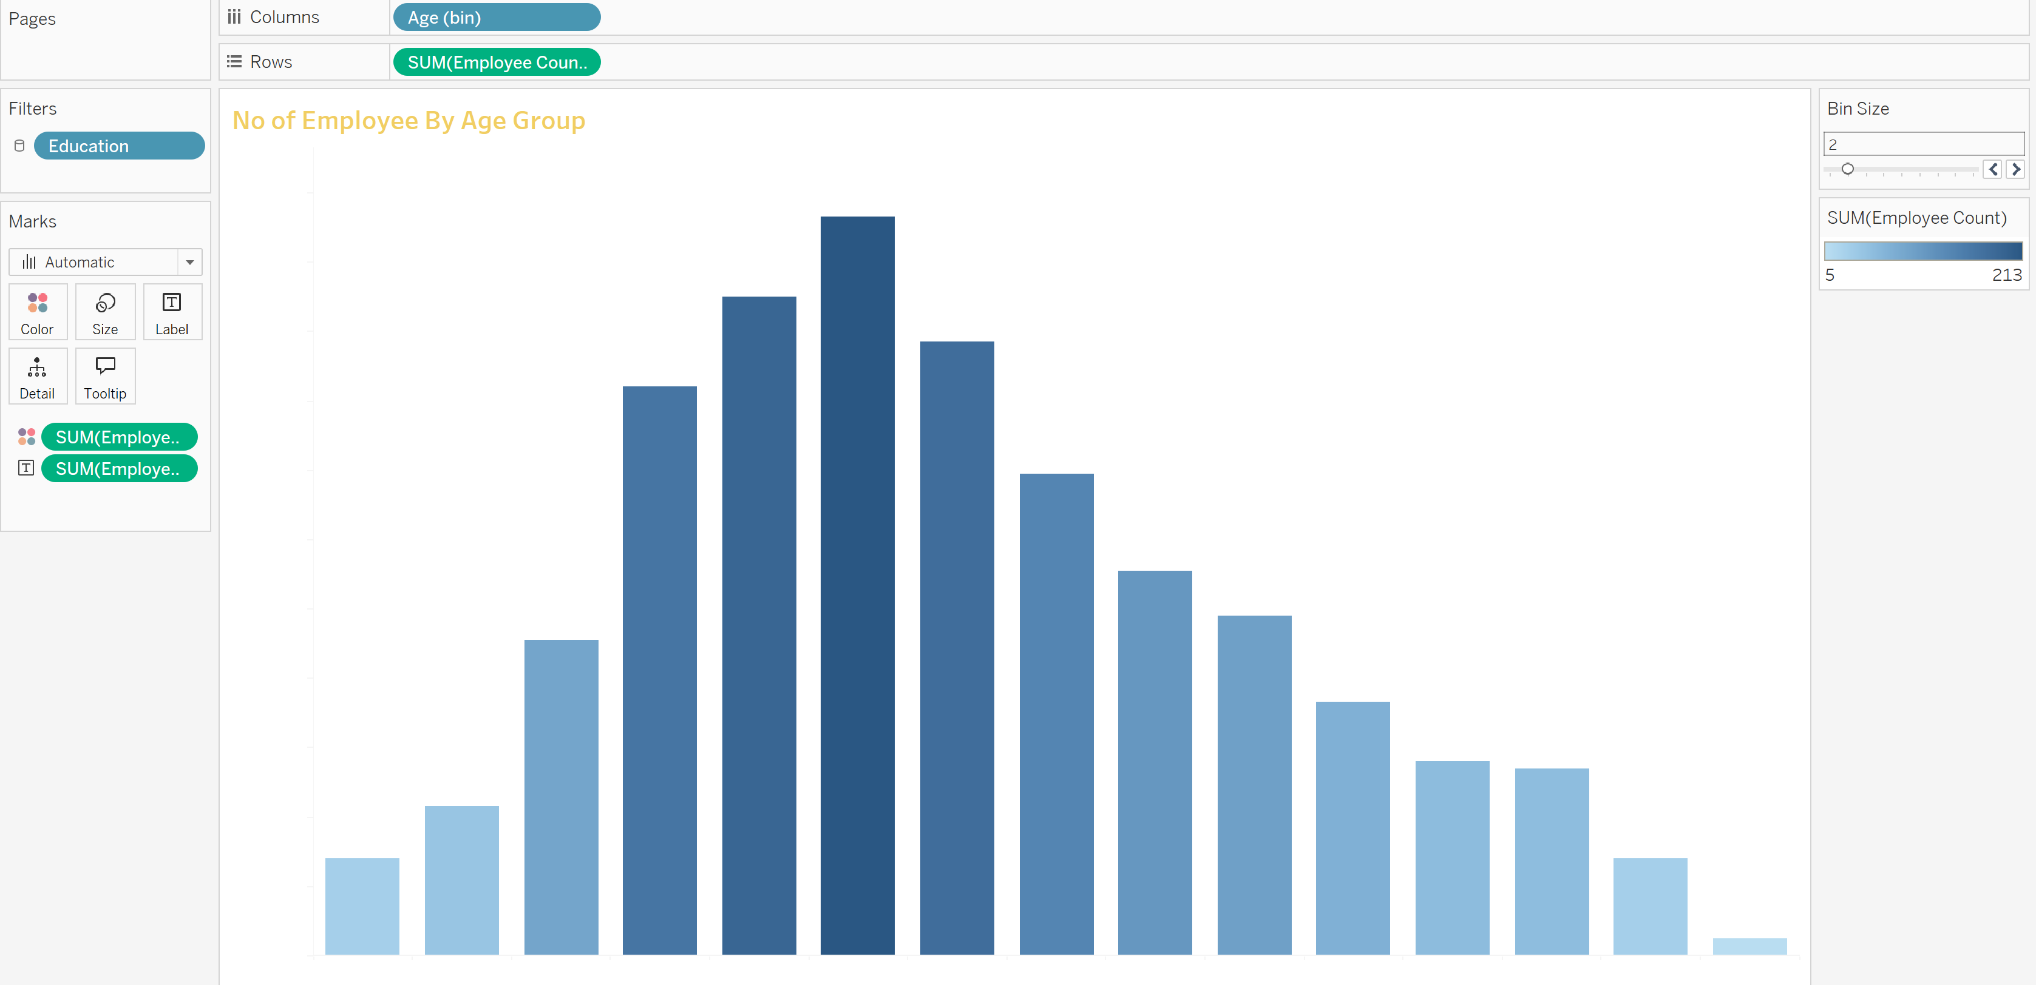



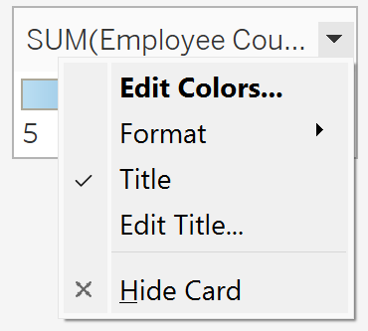



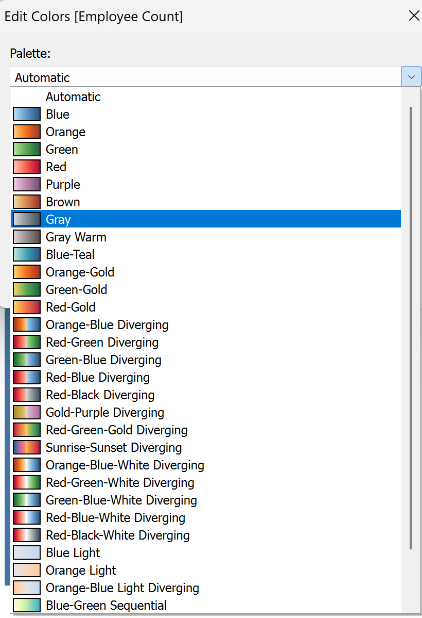



Now let me apply the filter and see the changes…

Matric Chart……

Now we have to make the “Job Satisfaction Ratings” chart.

Now we have to place the “Job Role” in rows and then the “Job Satisfaction” in the columns….

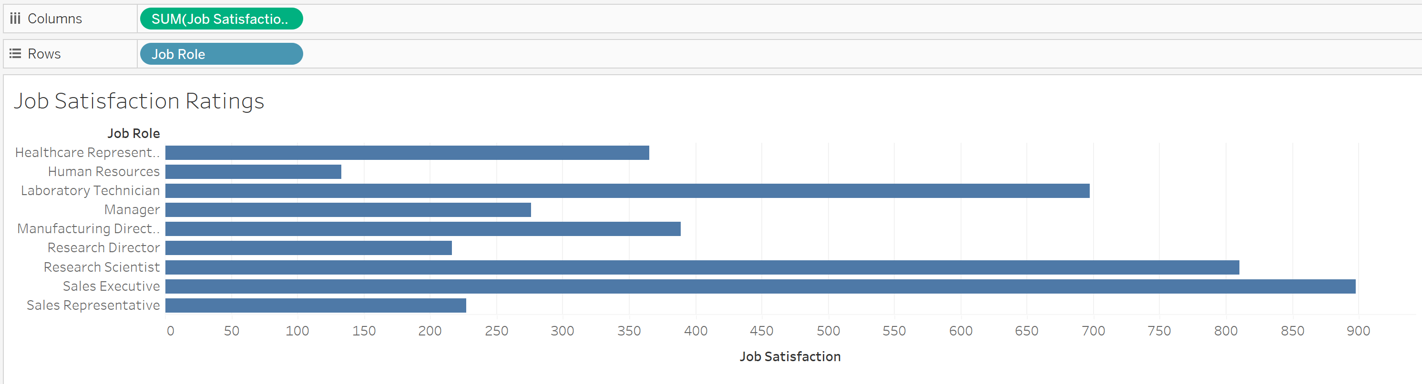

But we need numbers….

So for this we have to drag the “Job Satisfaction” in to the dimensions

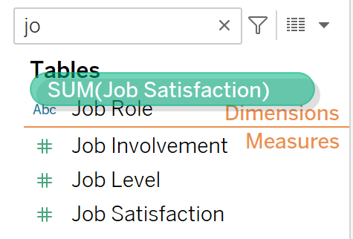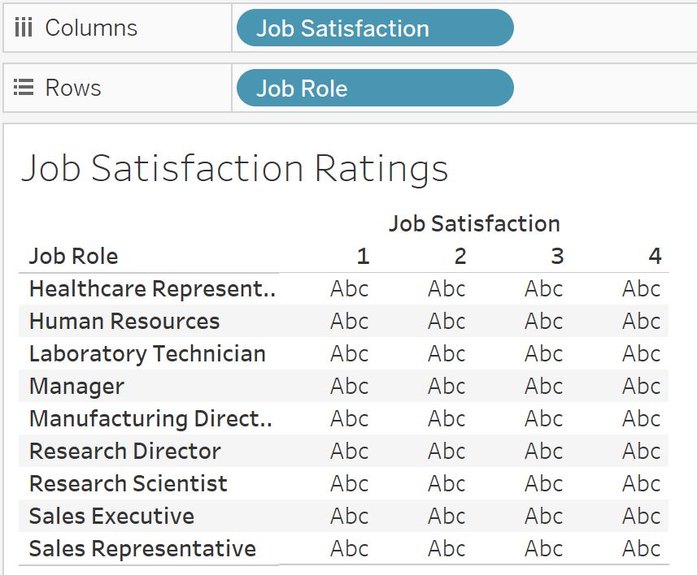

Now it is shown as categorical data….

Now to get the numbers instead of the “Abc” we have to drag the employee count on the Label…

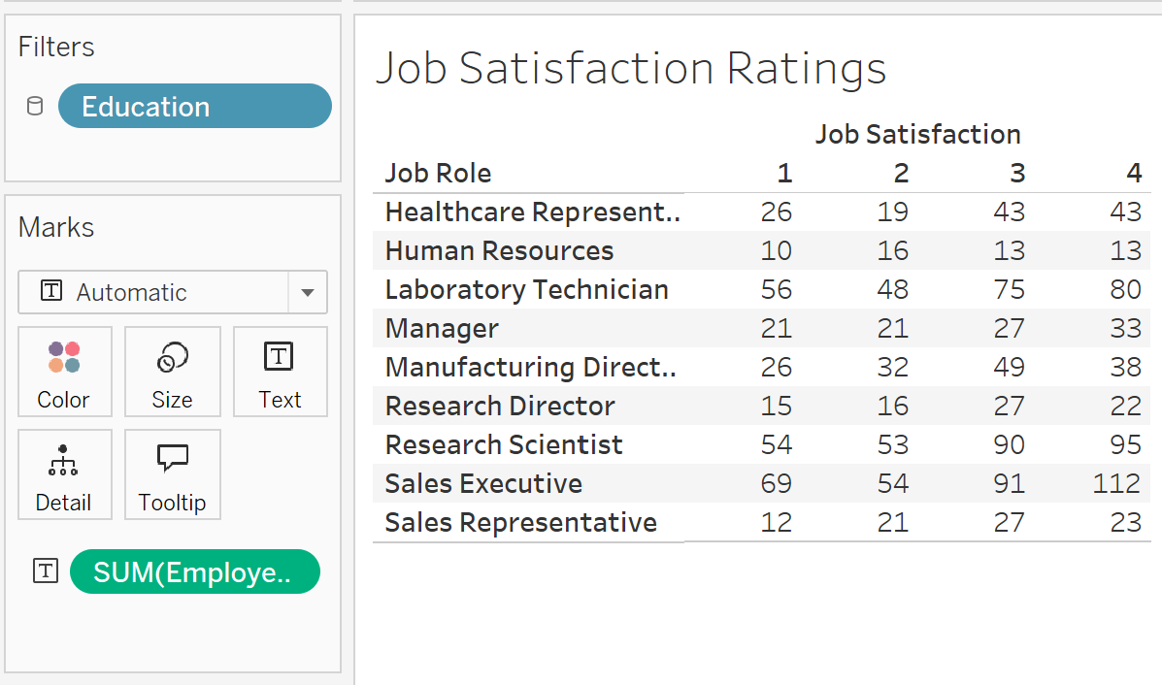

Now we have to add the “Column and Row Grand total”

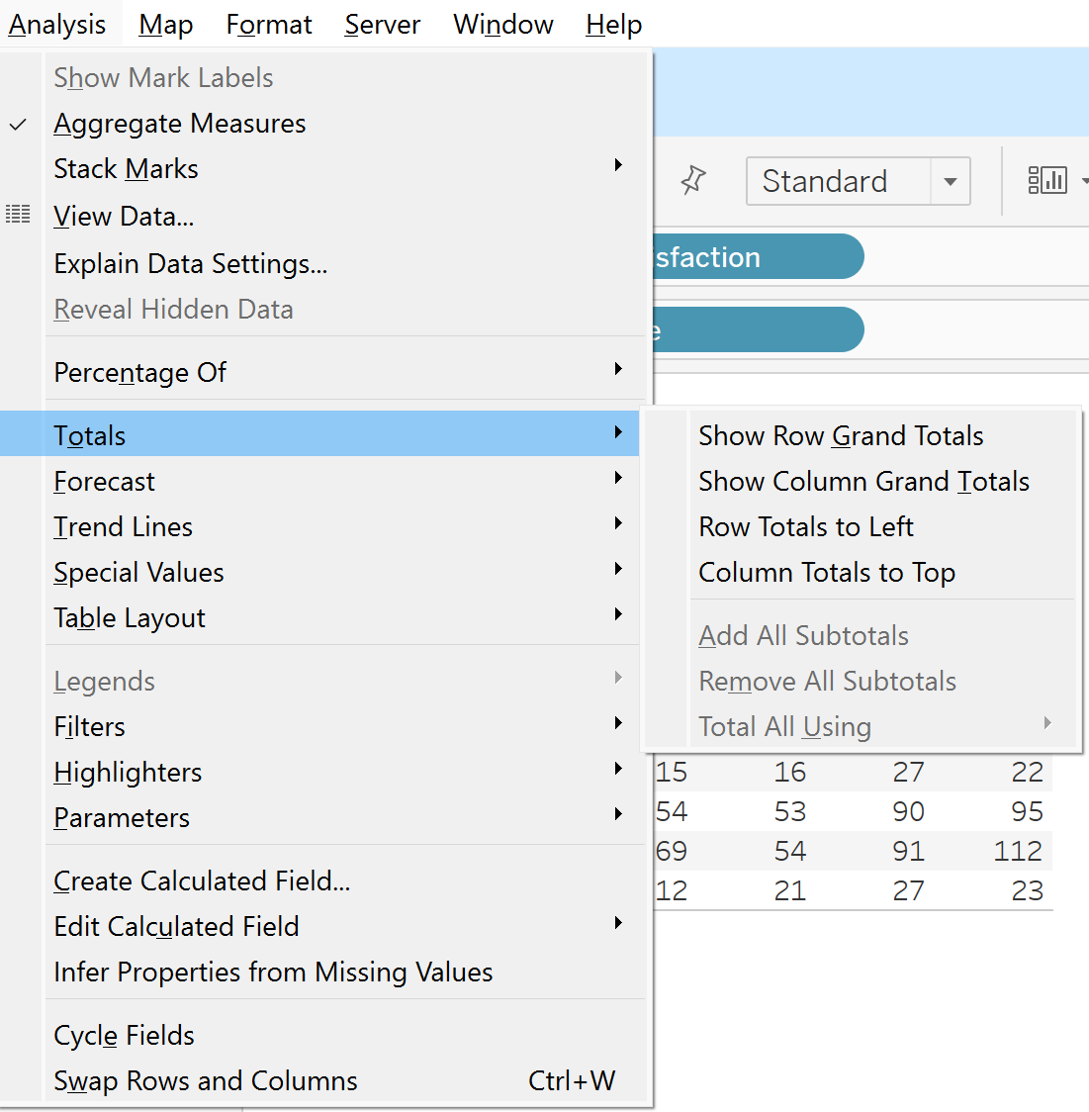



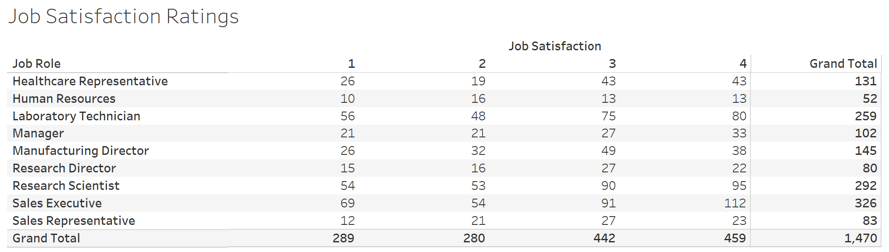



Now add it on the dash board and do the changes as needed..

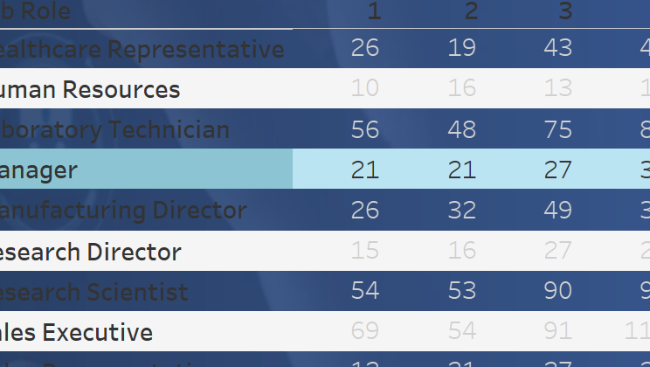

This is in the format of ROW BANDING so remove it from the pane…

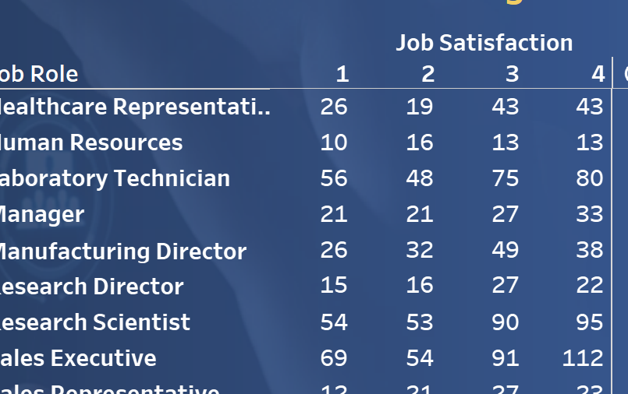

Now we have to change the color just like heat map…

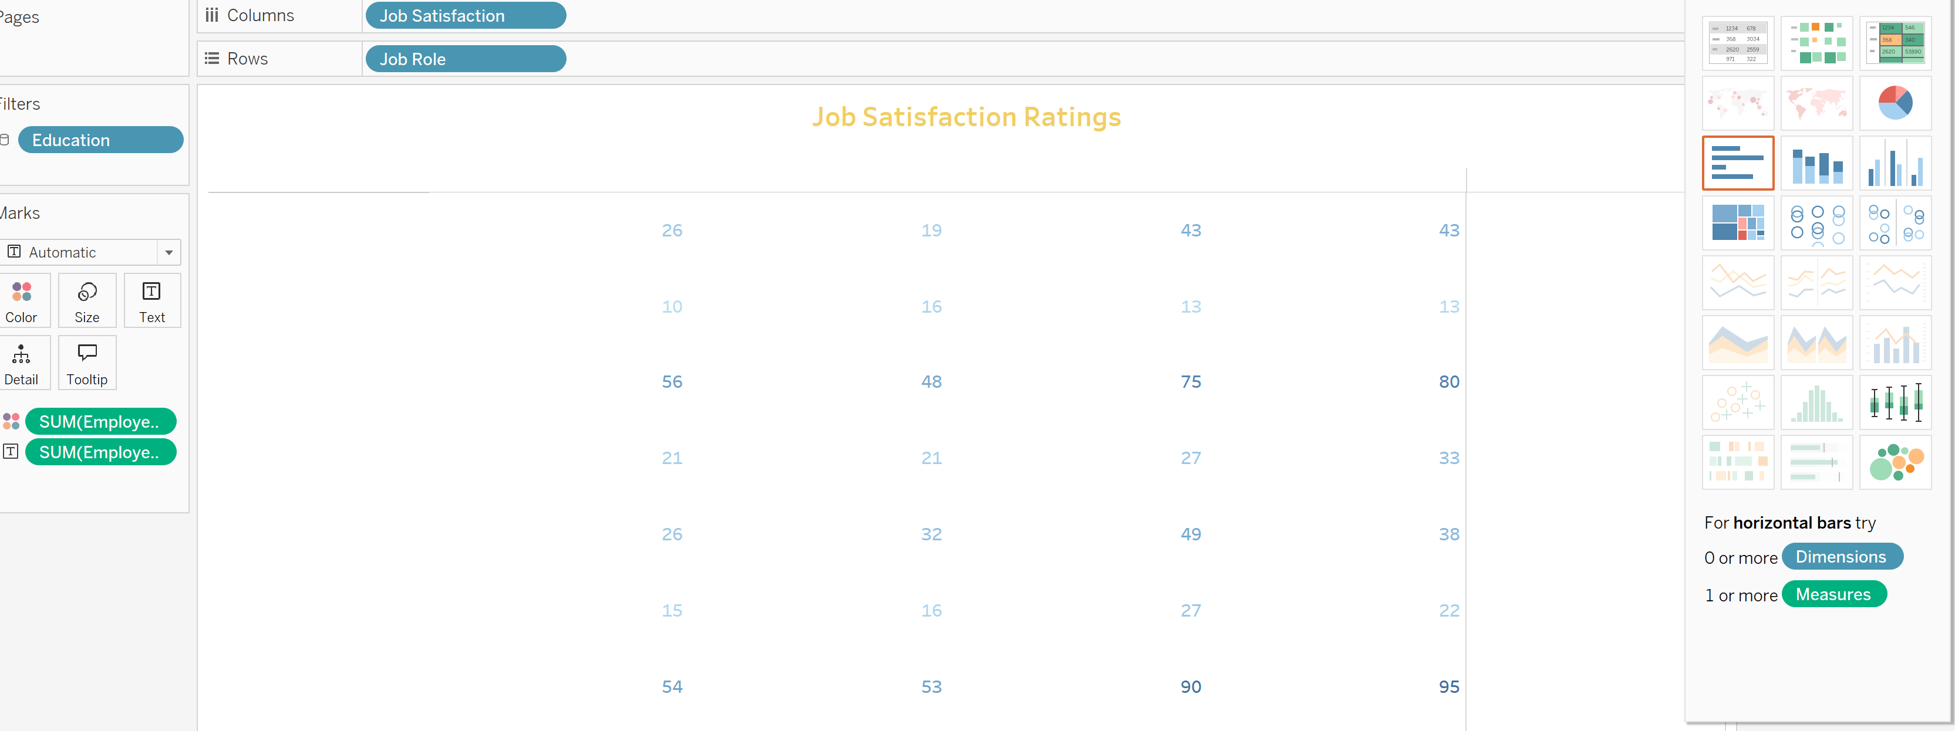



First drag the Label portion into the color by pressing ctrl and then choose the heat map…

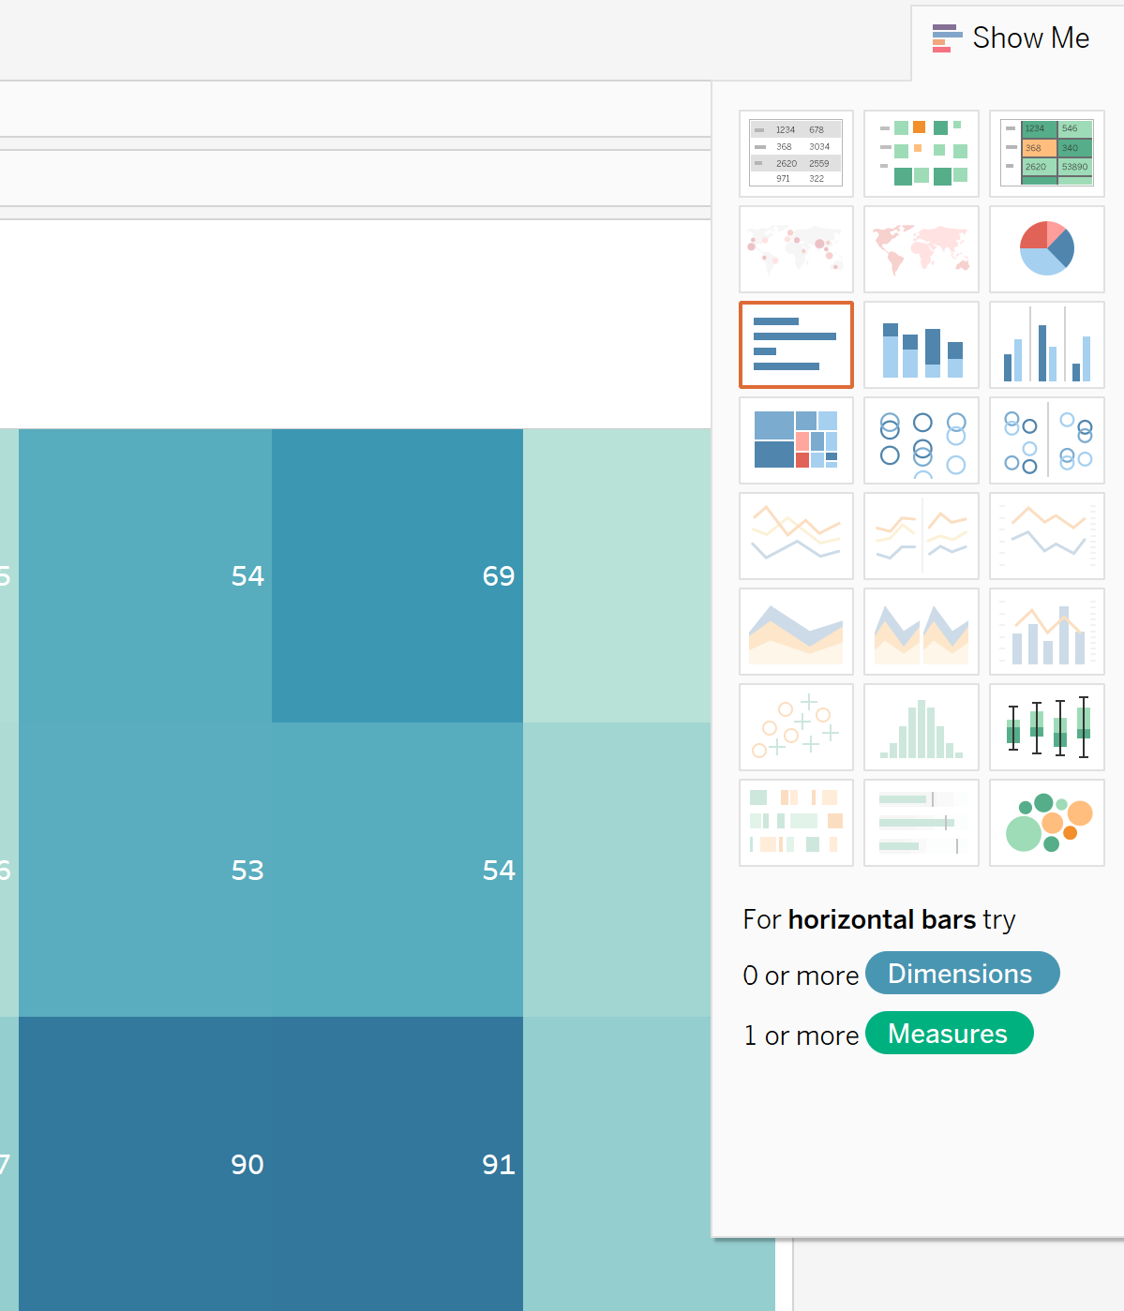

Now Next, we have to make the Bar Chart….

And new sheet named as “Education Field Wise Attrition”

Just take the Education Field in to the row and then the attrition in to the column..

Place the labels also….. by just putting it into the label…

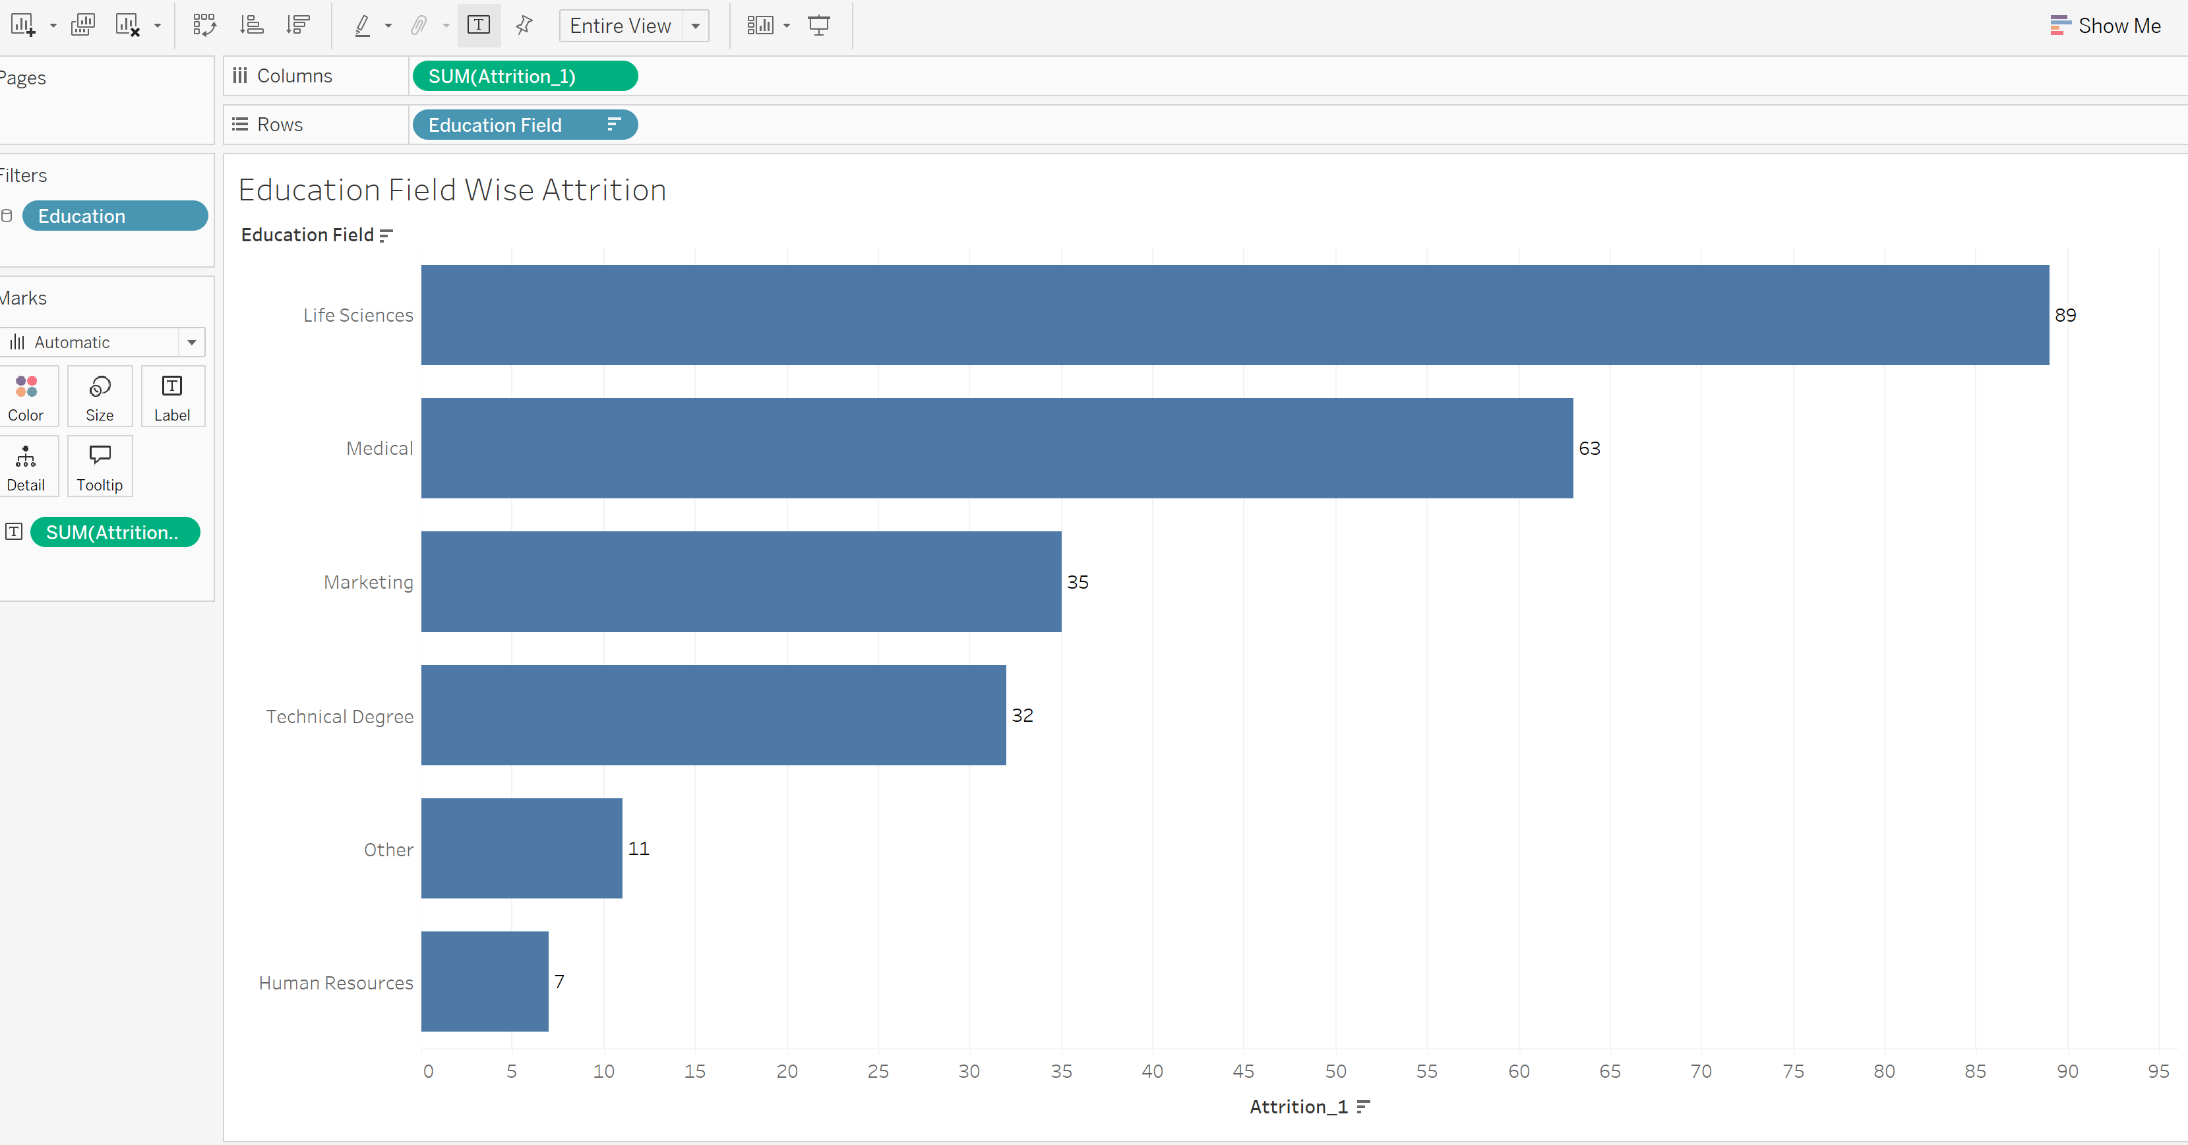



Now change the colors and all in dash board….

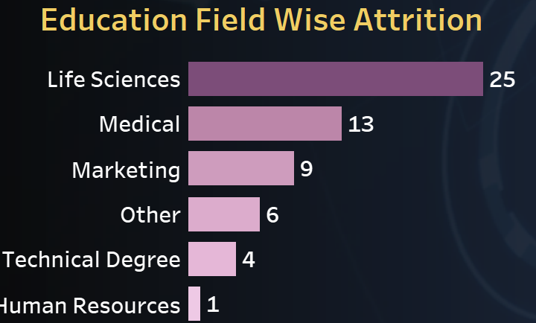

Now we have to make the “DONOT” Chart…

New sheet.

Now drag the CF age band field in the column and change the shape into the pie chart… from automatic…

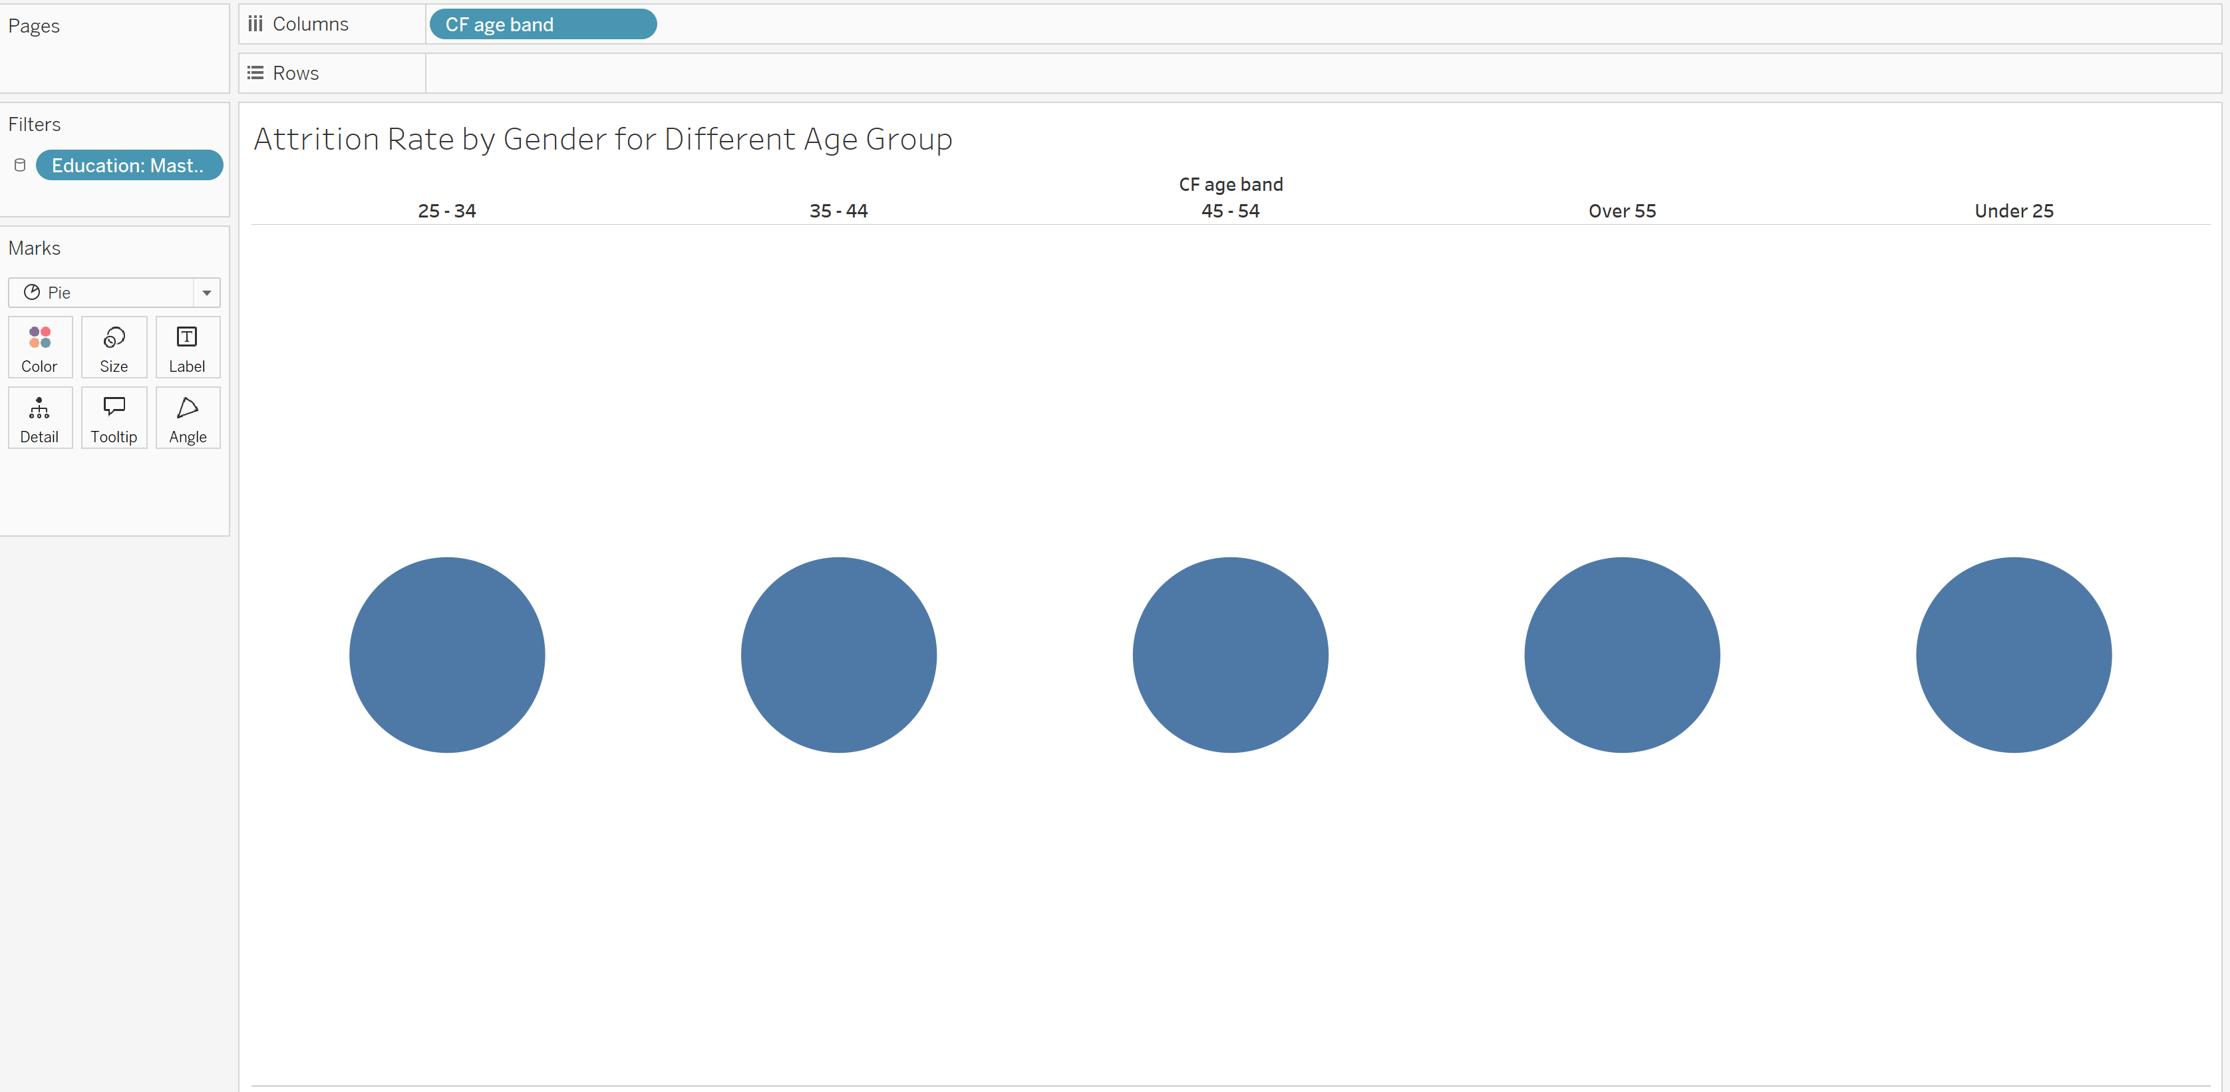



Now put the gender on to the color and then attrition on the angle so that we get the proper PIE charts…

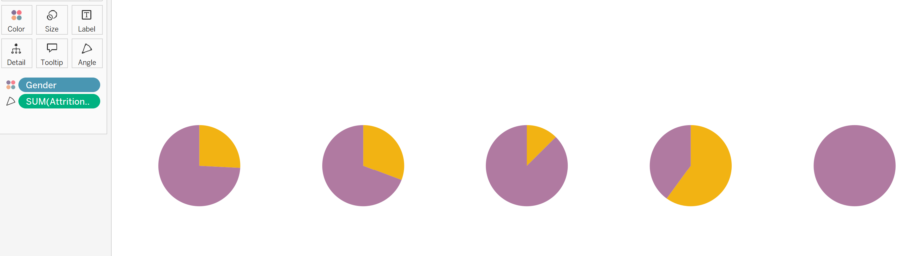

Now our turn is to change the chart into “Donut” Chart..

So for this we will create the two axis…

In the row column… double click and type…

Min(1)

And then drag it to the left with ctrl and

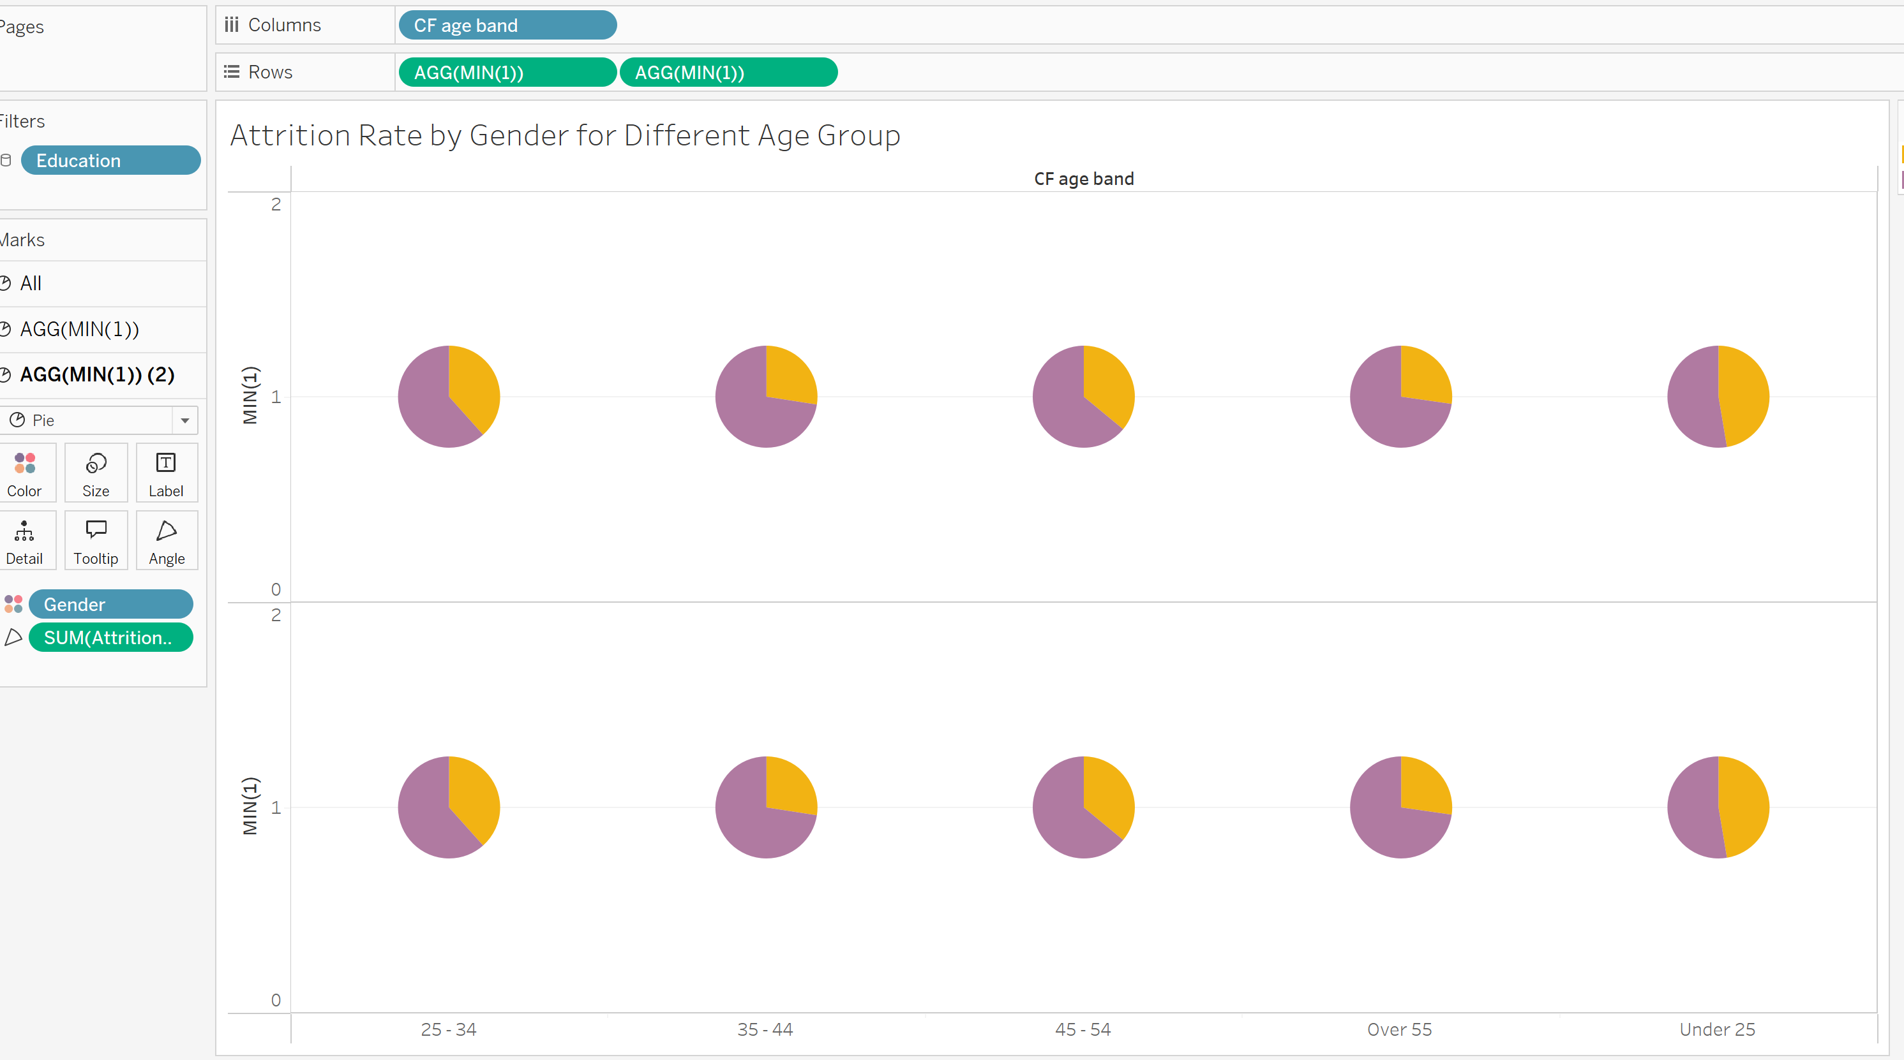



Now remove the Gender and Attrition from the second portion , decrease the size and then make it as Dual axis…

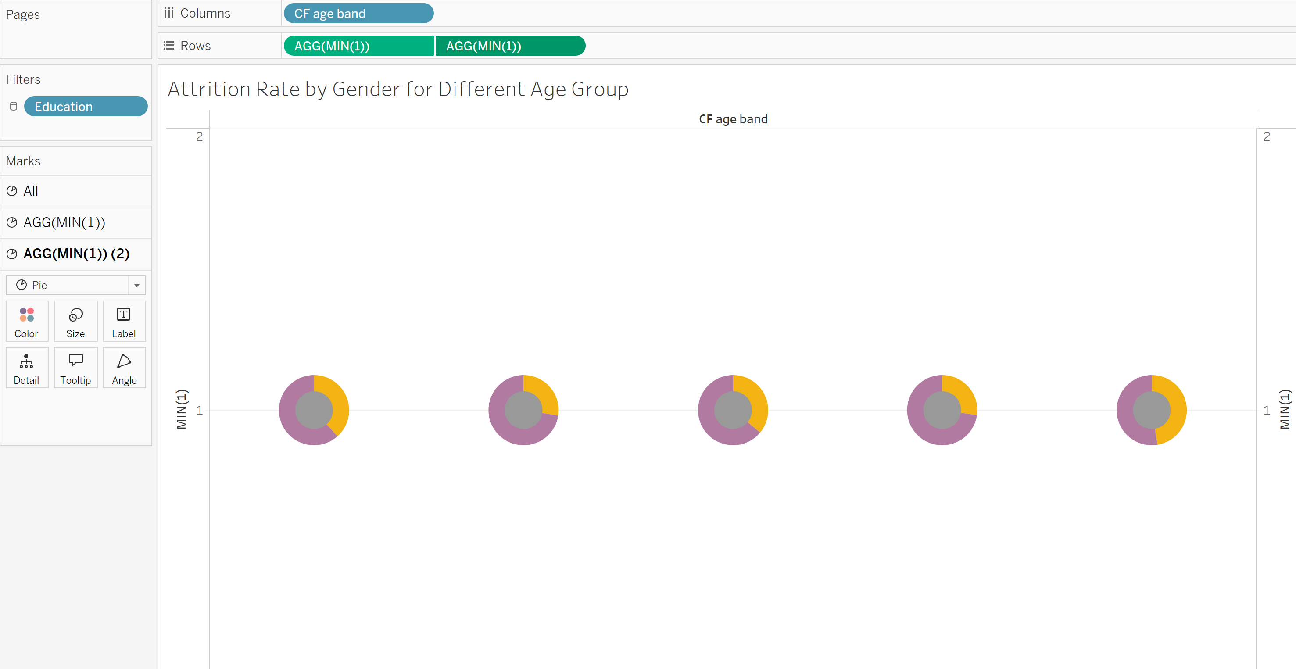



Now for labelling just drag the first one (AGG(Min(1)) onto the label…

And change it into the percentage….

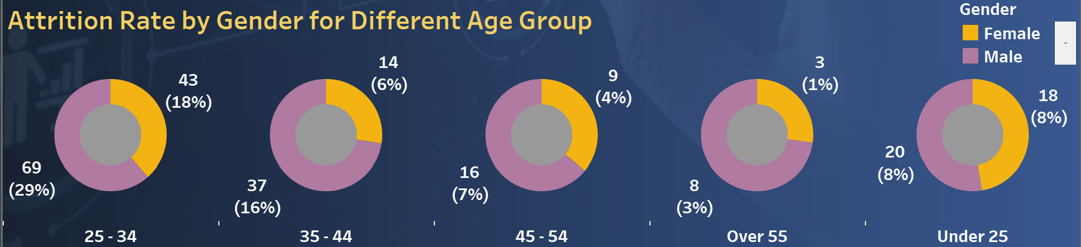

Now in the middle we have to put the total number as the attrition count or attrition_1

For this just drag the attrition_1 in the second AGG(MIN(1)) portion…

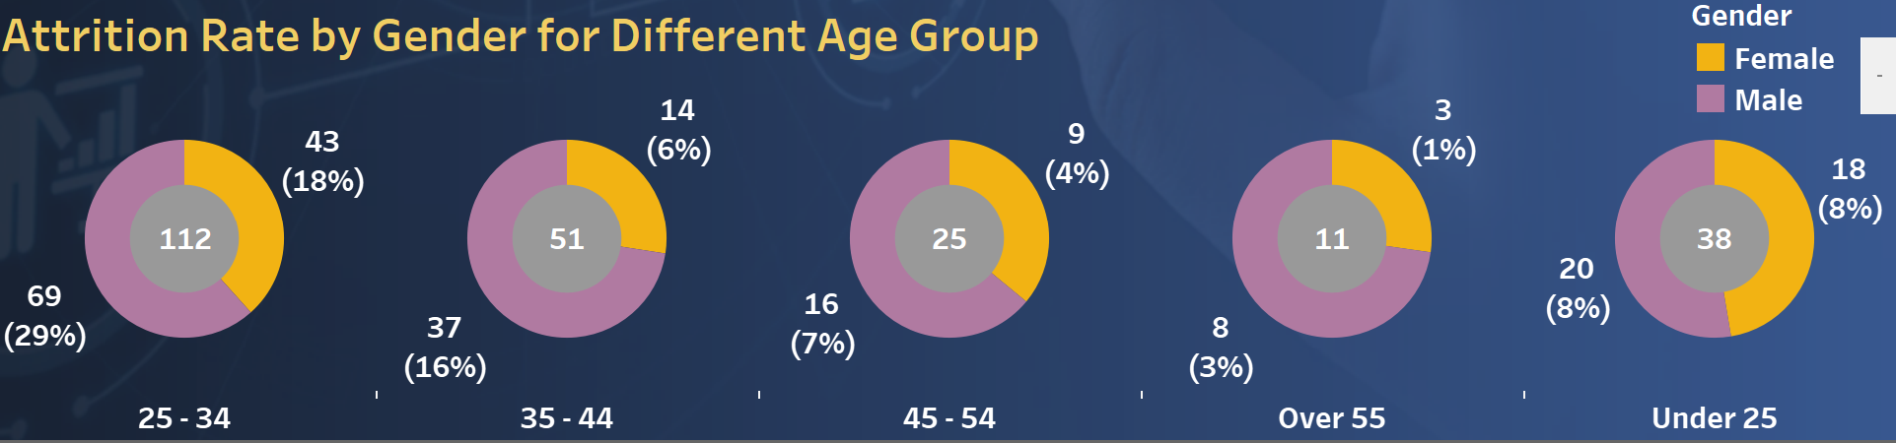

Now the age bands below is not in the proper fashion. Ascending or descending order so for this to be in proper format we have to go to the Sort

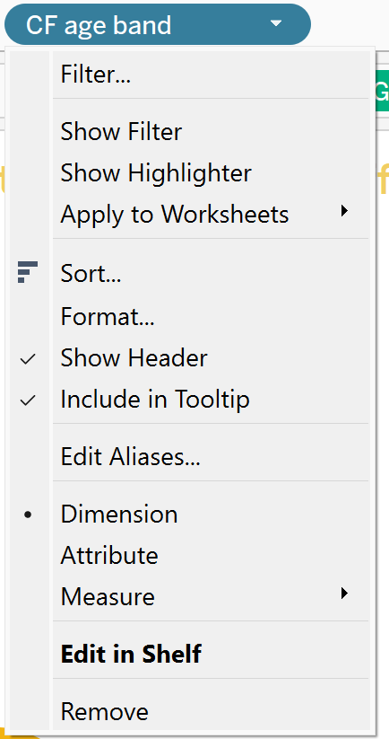



And then change it into the “Manual” and arrange it.

